DevOps / Azure Interview Preparation Guide 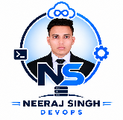
Neeraj Singh | NeerajSingh-DevOps (Neeraj singh)
Colour guide: Blue bold = key term Yellow highlight = IMPORTANT, zaroor yaad rakho

Mera Introduction (sabse pehle ye yaad karo)

Flow yaad rakhne ke liye
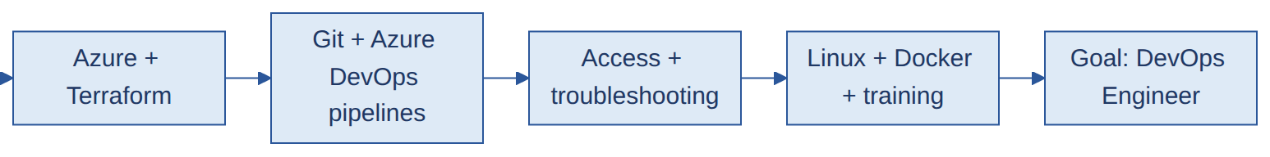
Bas ye 6 points yaad rakho. Words har baar thode alag ho sakte hain, flow wahi rahe.

1.5-minute intro (mock interview ke liye main yahi)
"Hi, I'm ________, from ______(Optional). I've been with _______ for about _____ years now, and right now I'm in the Cloud Support team, working mostly on Azure and DevOps.
My main work is building and managing Azure infrastructure with Terraform. Resource groups, VNets, subnets, VMs, I write all of that as code, and we reuse modules so the same setup works across environments. The code sits in Git, and Azure DevOps pipelines run it: init, validate, plan, and then apply once it's approved.
Besides that, I handle access requests for the environments, and I look into it when a pipeline or deployment fails. Usually it's a failed plan, a permission issue or a state lock. I also work on Linux and use Docker for basic containerization.
Alongside work, I'm doing a structured DevOps course and I've done the Terraform certification. I keep my practice projects on GitHub. What I like most about this work is taking something manual and turning it into code that anyone can rerun. I want to keep growing as a DevOps engineer, mainly around Azure, Terraform and CI/CD."

30-second version
"I'm ______, working with _____ in ______ for about ____ years. Currently I'm in the Cloud Support team, where I build Azure infrastructure with Terraform and run it through Azure DevOps pipelines. I also handle environment access and troubleshoot failed deployments. I've done the Terraform certification and I'm building more practice projects on Azure and Docker."

Jo follow-up zaroor aayega
"How much DevOps experience do you have?" "I've been at ______ for about three and a half years, and in my current Cloud Support and DevOps role I have around four months of hands-on experience, mainly on Azure, Terraform and Azure DevOps pipelines."
"What were you doing before this?" (sirf poochne par) "I was in finance operations at _____. I got interested in DevOps, took structured training, and moved internally into the Cloud Support team."
"What exactly do you do in your project?" Apne 3-4 asli kaam ke examples bolo: kaunsa resource Terraform se banaya, kaunsi pipeline fail hui aur kaise fix ki, kaunsa access issue handle kiya. (Ye examples aap mujhe bhejo, main answer bana dunga.)
Kaise use karna hai: Har topic mein pehle Samjho (concept), phir Picture (diagram), phir Q&A (sawal English mein jaise interviewer poochega, answer Hinglish mein samajhne ke liye; technical words English mein hi hain, wahi interview mein bolna). Pehle Samjho padho, phir Q&A ko apne words mein bolne ki practice karo. Rata mat lagao, 4-5 key points yaad rakho.
Level tags
- DEEP: aapke level par zaroor poochhega, strong karo
- MEDIUM: basic se thoda upar, clear concept rakho
- CONCEPT: sirf idea aur 2-3 line ka answer kaafi
Honest answering rule: Jahan sawal "Have you done X?" ho aur aapne nahi kiya, bolo: "I haven't done it in production, but I've practiced it in labs and I understand the flow: ...". Phir concept bol do. Interviewer ko ye believable lagta hai. Jo aapne sach mein kiya hai (Azure resources, Terraform, ADO pipeline, access, troubleshooting), usi ko apne project ke example se jodo.

Index
# | Tag | Topic | Level
1 | #TF-CORE | Terraform core | DEEP
2 | #TF-MODULES | Terraform modules | DEEP
3 | #TF-ADV | Drift, import, lifecycle, scenarios | DEEP
4 | #TF-PIPELINE | Terraform CI/CD pipeline | DEEP
5 | #CICD | Azure DevOps / GitHub Actions | DEEP
6 | #SECRETS | Key Vault, secrets, secret scanning | DEEP
7 | #TROUBLESHOOT | 502 / 503 and other troubleshooting | DEEP
8 | #DEVSECOPS | DevSecOps, SAST, DAST, SCA, SonarQube | MEDIUM
9 | #NETWORK | VNet, NSG, peering, NAT, LB vs AppGW vs Front Door | MEDIUM
10 | #PRIVATE | Private Endpoint and Private DNS | MEDIUM
11 | #IDENTITY | RBAC, Managed Identity, Entra ID, PIM | MEDIUM
12 | #VM-LINUX | VM access, Bastion, SSH, Linux tasks | MEDIUM
13 | #DOCKER | Docker basics | MEDIUM
14 | #GIT | Git and branching | MEDIUM
15 | #MONITOR | Azure Monitor, alerts, New Relic | MEDIUM
16 | #LZ | Landing Zone, Hub-and-Spoke, Firewall + UDR | MEDIUM
17 | #POLICY | Azure Policy and governance | CONCEPT
18 | #SUPPLY | Software supply chain, SBOM, vulnerabilities | CONCEPT
19 | #COST | Cost optimization | CONCEPT
20 | #DR | Backup, DR, HA, rollback | CONCEPT
21 | #MIGRATION | Cloud migration | CONCEPT
22 | #APPSVC | Azure App Service / PaaS | CONCEPT
23 | #SCRIPT | Scripting aur automation | CONCEPT
24 | #K8S | Kubernetes / AKS (common questions, basic level) | CONCEPT

Coverage map (aapki attached 28-topic list)
Attached list ka topic | Section | Attached list ka topic | Section
Landing Zone | 16 | 502 / 503 Troubleshooting | 7
Hub-and-Spoke / Networking | 16 | Azure Policy | 17
Azure Firewall + UDR | 16 | RBAC / IAM / Identity | 11
Terraform Core | 1 | Private Endpoint | 10
Terraform Modules | 2 | VM / Bastion / SSH / Linux | 12
Terraform Advanced | 3 | App Service / PaaS | 22
Terraform CI/CD | 4 | Monitoring / Observability | 15
Azure DevOps / GitHub Actions | 5 | Cost Optimization | 19
DevSecOps | 8 | Backup / DR / HA | 20
SAST / DAST / SCA / SonarQube | 8 | Cloud Migration | 21
Secrets / Key Vault | 6 | Scripting / Automation | 23
Supply Chain / SBOM | 18 | Git / Branching | 14
AKS / Kubernetes | 24 | Docker | 13
App Gateway / LB / Front Door | 9 | Networking Misc | 9

1. Terraform core #TF-CORE DEEP

Samjho
- Terraform ek IaC (Infrastructure as Code) tool hai. Infra ko code mein likhte ho, aur Terraform Azure mein wahi bana deta hai.
- Workflow: init (providers download, backend setup) → validate (syntax check) → plan (kya badlega dikhata hai) → apply (actual change).
- State file (terraform.tfstate) ek record hai: code ke kaunse resource Azure mein asli mein bane hain. Terraform plan isi state aur code ko compare karke banata hai.
- Remote backend: state ko team ke liye shared jagah (Azure Blob Storage) mein rakhte ho. Isse locking, versioning aur safety milti hai.
- State locking: jab ek aadmi apply chala raha hota hai to state lock ho jati hai, taaki doosra usi waqt na chalaye. Azure Blob backend mein ye blob lease se hota hai.

Diagram: Terraform workflow
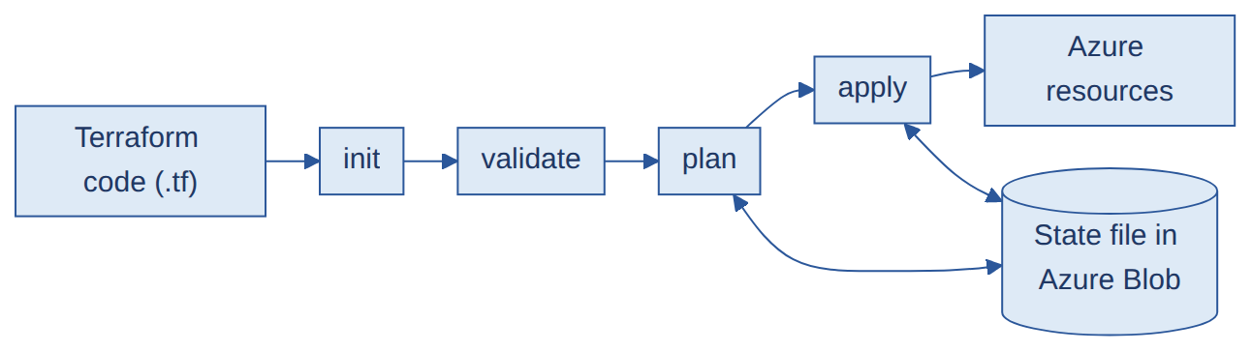

Diagram: State locking: do log ek saath apply karein to kya hota hai
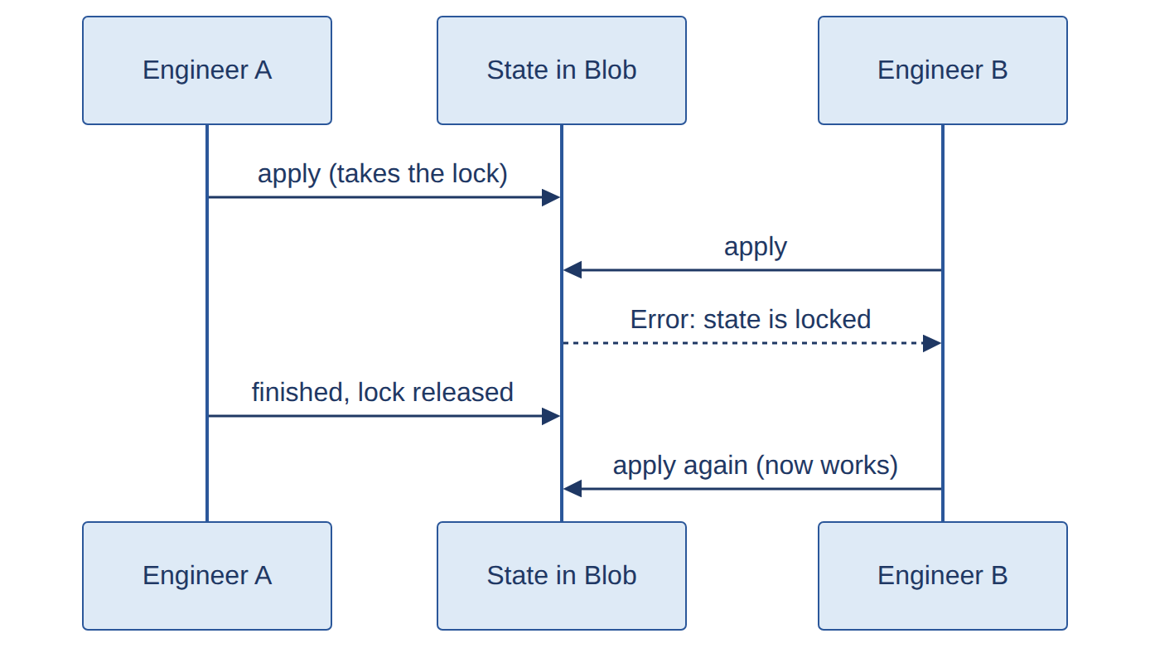

Q&A
Q1. What is Terraform and IaC?
A. Terraform ek open-source IaC (Infrastructure as Code) tool hai. Hum infrastructure ko code mein likhte hain aur Terraform Azure mein wahi bana deta hai. Isse kaam repeatable hota hai, Git mein version control hota hai aur review bhi ho jata hai.
Q2. Explain the Terraform workflow.
A. init se providers aur backend set hote hain, validate syntax check karta hai, plan dikhata hai ki kya change hoga, aur apply (approval ke baad) actual change karta hai.
Q3. What is the state file?
A. Ye ek record hai ki mere code ke kaunse resources Azure mein actually bane hain. Terraform state, code aur real infra ko compare karke decide karta hai ki kya create, change ya destroy karna hai.
Q4. Why store state remotely?
A. Team ke liye. Azure Blob backend mein ek shared state milti hai, saath mein locking, versioning aur access control. State kisi ke laptop par nahi rehti.
Q5. What is state locking? Two engineers run apply together, what happens?
A. Ek time par ek hi operation state par chal sakta hai. Doosre engineer ko "state locked" error aata hai (ya wait karta hai) jab tak pehla run khatam na ho jaye.
Q6. When do you use `terraform force-unlock`? Precautions?
A. Jab lock atak jaye, jaise pipeline crash hone ke baad. Pehle confirm karo ki koi apply chal nahi raha, phir terraform force-unlock <LOCK_ID> chalao. Chalte hue run mein unlock kiya to state corrupt ho sakti hai.
Q7. State file corrupt ho gayi. Recover kaise karoge?
A. Storage account se previous version restore karo (blob versioning ya soft delete se). Wo na mile to existing resources ko import karke plan chalao jab tak koi diff na aaye. Bachav ke liye versioning on rakho aur state par access limited rakho.
Q8. Local state ko remote backend mein kaise migrate karte ho?
A. backend "azurerm" block add karo aur terraform init -migrate-state chalao. Terraform confirmation maangta hai aur state copy kar deta hai.
Q9. State mein sensitive data ko kaise protect karte ho?
A. State mein secrets plain text mein ho sakte hain. Isliye secured storage account (RBAC + encryption, public access band), secrets Key Vault mein, variables/outputs par sensitive = true, aur state ko kabhi Git mein commit nahi karte.
Q10. `required_providers` vs `provider` block?
A. required_providers (terraform block ke andar) batata hai kaunsa provider aur kaunsa version chahiye. provider block us provider ko configure karta hai, jaise features {} aur subscription.
Q11. Terraform Cloud/Enterprise vs vanilla (plain) Terraform?
A. Vanilla Terraform mein CLI mere apne backend aur pipeline ke saath chalta hai. Terraform Cloud/Enterprise mein hosted remote runs, state management, team access control aur policy checks milte hain.
Q12. Terraform Enterprise mein state kaise manage hoti hai? Local Terraform na ho to locked state kaise resolve karoge?
A. State har workspace ke saath store hoti hai (versioned, encrypted, access controlled). Run atak gaya ho to UI mein run ko cancel/discard karte hain ya workspace settings se unlock karte hain, local Terraform ki zarurat nahi padti.
Q13. AzureRM vs AzAPI provider? AzAPI kab use karte ho?
A. AzureRM mein ready-made resource-specific blocks hote hain. AzAPI Azure REST API ko seedha call karta hai, isliye jo naye ya preview features AzureRM mein abhi nahi aaye wahan AzAPI use karte hain.

2. Terraform modules #TF-MODULES DEEP

Samjho
- Module = Terraform code ka reusable folder. Ek baar likho, Dev/UAT/Prod mein baar baar use karo.
- Root module: jis folder mein aap terraform apply chalate ho. Child module: jise root module block se call karta hai.
- Modules aapas mein kaise baat karte hain: ek module ka output doosre module ka input variable ban jata hai, root ke through. Jaise VNet module subnet_id output deta hai, VM module use input leta hai.
- Standard files: main.tf (resources), variables.tf (inputs), outputs.tf (outputs), versions.tf (provider/version).
# Root module calling child modules
module "network" {
source = "./modules/vnet"
name = "vnet-dev"
location = var.location
}

module "vm" {
source = "./modules/vm"
subnet_id = module.network.subnet_id # output of one module -> input of another
}

Diagram: Modules ek doosre se kaise baat karte hain
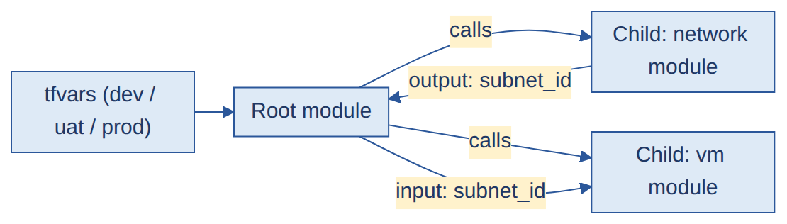

Q&A
Q1. What is a module? Root vs child?
A. Module reusable Terraform files ka set hota hai. Root module wo hai jahan se main Terraform run karta hu, aur child module ko root module block se call karta hai.
Q2. Root se child, aur modules ke beech values kaise pass karte ho?
A. Root se child ko input variables se. Modules ke beech outputs se: jaise VNet module subnet_id output deta hai, aur root use VM module ko input bana deta hai.
Q3. Modules ke beech dependencies kaise handle hoti hain?
A. Terraform references (jaise module.network.subnet_id) dekhkar khud dependency graph bana leta hai. Jahan dependency dikhti nahi, wahan depends_on use karte hain.
Q4. `main.tf`, `variables.tf`, `outputs.tf` mein kya rakhte ho?
A. main.tf mein resources, variables.tf mein inputs (type aur default ke saath), outputs.tf mein wo values jo doosre modules ko chahiye, jaise IDs.
Q5. Storage Account module kaise design karoge?
A. Inputs: name, resource group, location, tier, replication, tags. Resource: azurerm_storage_account (aur zarurat ho to container). Outputs: storage account ID aur name. Secure defaults jaise TLS 1.2 aur public blob access band.
Q6. Modules ko version aur share kaise karte ho?
A. Modules ko apne Git repo mein rakho aur release tag lagao, phir source = "git::<repo>?ref=v1.2.0" se use karo (ya private registry). Har environment ek version pin karta hai, isliye change pehle Dev mein test hota hai.
Q7. Dev / UAT / Prod kaise structure karte ho?
A. Reusable modules ek hi rehte hain. Har environment ka alag folder ya tfvars file hoti hai, apni values aur apni state file key ke saath.
Q8. DRY principle kaise follow karte ho?
A. Repeated patterns ke liye modules, shared values ke liye locals, aur ek map par for_each lagakar ek hi block se kai similar resources banate hain.
Q9. Private modules banaye hain? Enterprise-level reusable modules kaise design karoge?
A. Apne Git repo ya private registry mein modules rakhte hain. Design: ek module ek kaam (VNet, VM, Storage), inputs validated, secure defaults, outputs clear, README aur version tags. (Agar aapne khud nahi banaya to bolo: "Maine practice mein banaye hain aur existing modules consume kiye hain.")
Q10. `locals`, `tfvars`, `for_each` aur maps ek saath kaise use karte ho?
A. tfvars mein per-environment values (map), locals mein derived/shared values, aur for_each us map par chalkar ek hi block se kai resources banata hai. Example:
# terraform.tfvars
vms = {
web = { size = "Standard_B2s" }
app = { size = "Standard_B2ms" }
}
# main.tf
resource "azurerm_linux_virtual_machine" "vm" {
for_each = var.vms
name = "vm-${each.key}"
size = each.value.size
}

3. Drift, import, lifecycle, scenarios #TF-ADV DEEP

Samjho
- Drift: real infra code/state se alag ho gaya, jaise kisi ne portal se NSG rule badal diya. terraform plan isse dikha deta hai.
- Import: pehle se bane (manual) resource ko Terraform ke under lana.
- Lifecycle block: resource ke behavior ko control karta hai: create_before_destroy, prevent_destroy, ignore_changes.
- Meta-arguments: count, for_each, depends_on, provider, lifecycle.

Diagram: Drift ka poora cycle
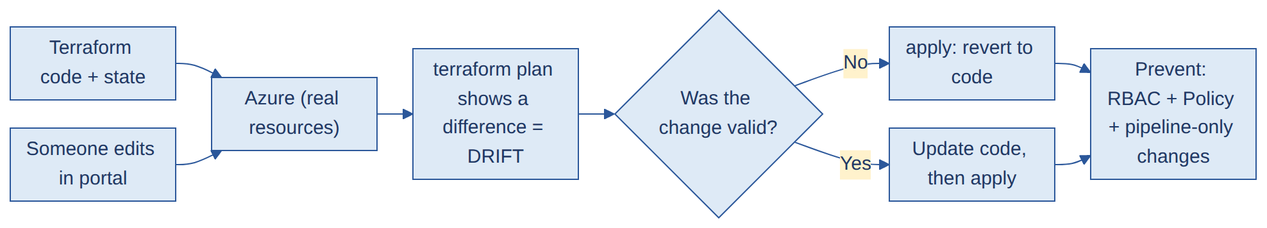

Diagram: Import ka flow
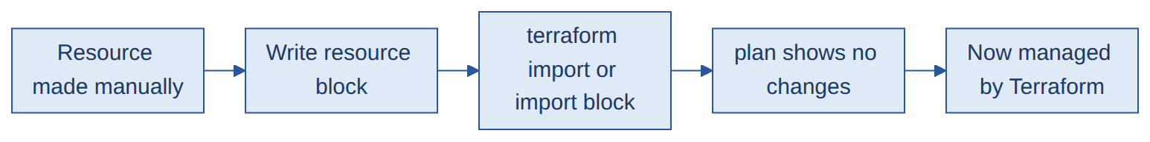

Q&A
Q1. Drift kya hai? Detect, resolve aur prevent kaise karte ho?
A. Drift matlab real infra code se alag ho gaya, jaise kisi ne portal se change kar diya. terraform plan se detect hota hai. Resolve: ya to apply karke change revert karo, ya change valid tha to code update karo. Prevent: portal write access RBAC se limit karo, sab changes pipeline se karo, aur Azure Policy guardrails lagao.
Q2. Code change nahi kiya phir bhi Terraform changes dikha raha hai. Kyun?
A. Aksar drift hota hai (kisi ne manually change kiya), ya provider version badla, kisi default value badli, ya module version update hua.
Q3. Resource manually bana hai. Terraform ke under kaise laoge?
A. Resource block likho, phir terraform import ya import block se import karo (resource address aur Azure resource ID chahiye), aur plan chalao jab tak "no changes" na aaye.
Q4. `data` block kya hai?
A. Ye ek existing resource ko read karta hai jo Terraform manage nahi karta, jaise data "azurerm_resource_group", taaki uska ID ya properties reference kar sako.
Q5. `null_resource` kya hai?
A. Ye cloud mein kuch create nahi karta. triggers aur provisioners ke saath scripts chalane ke kaam aata hai. Ye last option hai, tab use karte hain jab koi proper resource available na ho.
Q6. `lifecycle` block kya hai? `create_before_destroy` kya karta hai?
A. Ye Terraform ke replace/protect behavior ko control karta hai. create_before_destroy pehle naya resource banata hai, phir purana delete karta hai, isse downtime nahi hota. prevent_destroy accidental delete rokta hai. ignore_changes kuch attributes ko ignore karta hai.
Q7. `depends_on` kya hai?
A. Jab Terraform references se dependency nahi samajh paata, tab depends_on se explicit order force karte hain.
Q8. `count` vs `for_each`?
A. count index ke hisaab se N copies banata hai, aur beech ka item hataya to baaki shift ho jate hain. for_each map ya set ke stable keys use karta hai, isliye har resource naam se track hota hai. Main for_each prefer karta hu.
Q9. Sirf ek corrupt VM ko redeploy kaise karoge?
A. terraform apply -replace="azurerm_linux_virtual_machine.vm1" (purana tarika terraform taint). Sirf wahi VM destroy hokar dobara bante hai.
Q10. Terraform ko safely upgrade kaise karte ho?
A. Release notes padho, pehle Dev mein test karo, required_version pin karo, state ka backup lo, terraform init -upgrade chalao, phir plan se check karo ki koi unexpected change na aaye.
Q11. Pipeline succeed hui par Azure resource nahi bana. Kyun?
A. Check karo: plan mein no changes tha, galat subscription ya backend/state key, apply stage skip hui ya approval nahi mila, count = 0 ya koi condition, -target use hua, ya resource kisi aur resource group mein ban gaya.
Q12. ClickOps resources ko Terraform mein kaise laate ho?
A. Existing resources ki list banao, code likho (ya aztfexport use karo), import karo, plan chalao jab tak diff na aaye, aur uske baad sab changes pipeline se karo.
Q13. Terraform Workspaces kya hain? Kab use karte ho aur kab separate folders?
A. Workspace ek hi code ke liye alag state files deta hai (dev, uat, prod). Simple, identical environments ke liye theek hai. Prod ke liye alag folder/state behtar hai kyunki galat workspace mein apply hone ka risk rehta hai.
Q14. Terraform aur provider version compatibility kaise handle karte ho?
A. required_version aur provider versions pin karte hain (jaise ~> 3.0), aur .terraform.lock.hcl ko Git mein commit karte hain taaki sab ek hi version use karein.
Q15. Terraform upgrade mein kya challenges aate hain?
A. Deprecated arguments, breaking changes in provider, aur state format changes. Isliye ek major version ek baar mein, pehle Dev mein test, aur state ka backup.
Q16. Terraform deployment failures ko monitor kaise karte ho?
A. Pipeline failure par Teams/email notification, run logs aur history, aur scheduled terraform plan -detailed-exitcode (exit code 2 = changes mile) se drift detect karke alert.
Q17. Koi real Terraform failure jo aapne resolve kiya? (apne example se replace karo)
A. Sample: "Pipeline cancel hone par state lock reh gayi. Maine confirm kiya ki koi apply nahi chal raha, force-unlock kiya, aur plan chalakar state healthy check ki." (Aap apna asli example yahan lagao.)
Q18. Infra ko ek cloud account se doosre mein, ya minimal downtime ke saath kaise migrate karte ho?
A. Naya environment parallel mein Terraform se banao, existing resources ko import ya state mv se map karo, traffic DNS/load balancer se switch karo, phir purana hatao. Data migration alag plan hota hai.
Q19. Nested maps kab use karte ho?
A. Jab ek resource ki kai properties ko groups mein dena ho, jaise subnets ka map jisme har subnet ke andar address aur NSG ho. for_each map of objects par chalta hai.
Q20. Import mein kaunsi files/cheezein chahiye?
A. Resource ka config block aur Azure resource ID. Terraform 1.5+ mein import block use hota hai, aur terraform plan -generate-config-out se config bhi generate ho sakta hai.

4. Terraform CI/CD pipeline #TF-PIPELINE DEEP

Samjho
Infra pipeline ka flow: Checkout → security/lint checks → init → validate → plan → (approval) → apply.
- Plan ko file mein save karte ho (terraform plan -out=tfplan) aur artifact banate ho, taaki apply wahi plan chalaye jo approve hua.
- Approval ke liye Azure DevOps Environment approvals ya manual validation use hota hai.

Diagram: Terraform pipeline
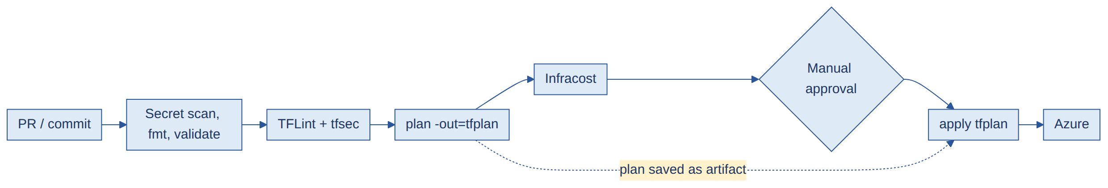

Q&A
Q1. Terraform pipeline kaise design karoge?
A. Stages: checks (fmt, validate, TFLint, tfsec, secret scan), plan (plan ko artifact banao), approval, phir wahi plan apply karo. Azure login service connection se hota hai.
Q2. init, plan, apply ko alag kaise karte ho aur plan kaise pass karte ho?
A. Plan stage terraform plan -out=tfplan chalata hai aur use pipeline artifact publish karta hai. Apply stage use download karke terraform apply tfplan chalata hai, isliye wahi change apply hota hai jo approve hua tha.
Q3. Apply se pehle approval kaise lagate ho?
A. Azure DevOps Environment par approvers set karte hain, to pipeline apply stage par ruk jati hai jab tak koi approve na kare.
Q4. tfsec, TFLint, Gitleaks/TruffleHog, Infracost kahan lagate ho?
A. TFLint (code quality) aur tfsec (security misconfiguration) plan se pehle, secret scan sabse pehle step mein. Infracost plan ke baad chalta hai taaki approval se pehle cost impact dikhe.
Q5. Developers in checks ko bypass na karein, iske liye kya karte ho?
A. PR par build validation wali branch policies, pipeline YAML ko protected repo ya shared template mein rakhna, edit permissions limited, aur prod environment par approvals.
Q6. 20+ cloud accounts mein Terraform ko standardize kaise karoge?
A. Shared versioned modules, ek common template pipeline, same folder structure, aur policy checks.
Q7. Cost estimation kis stage par karte ho?
A. plan ke baad, Infracost plan se cost calculate karke PR ya approval se pehle dikhata hai.

5. Azure DevOps / GitHub Actions #CICD DEEP

Samjho
- YAML pipeline hierarchy: trigger → pool (agent) → stages → jobs → steps → tasks. Saath mein variables, parameters, artifacts, environments.
- Service connection: Azure DevOps ko Azure se jodne wala connection (Service Principal ya Workload Identity Federation).
- Agent: Microsoft-hosted (Microsoft manage karta hai, fresh VM) ya self-hosted (aapka apna VM, apne VNet mein).
- CI = build + test. CD = deploy. Multi-stage pipeline = Build → Test → Dev → UAT → Prod, approvals ke saath.

Diagram: YAML pipeline ki hierarchy
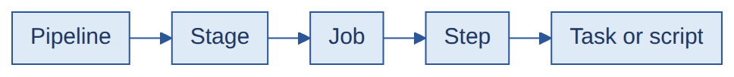

Diagram: Multi-stage CI/CD

Q&A
Q1. Apni pipeline ka flow samjhao.
A. Code commit par pipeline trigger hoti hai. Build aur test chalte hain, artifact publish hota hai, phir stage by stage deploy hota hai (Dev, UAT, Prod), aur upar ke environments par approvals lagte hain.
Q2. Stage, job, step, task kya hain?
A. Stage ke andar jobs hote hain, job ke andar steps, aur step ek task ya script chalata hai. Jobs parallel chal sakte hain, stages order mein chalte hain.
Q3. PR validation kaise implement karte ho?
A. main par branch policy lagate hain with build validation. Jab tak pipeline pass na ho aur reviewers approve na karein, PR merge nahi hota.
Q4. Microsoft-hosted vs self-hosted agent?
A. Microsoft-hosted agent managed hota hai aur har run par fresh milta hai, par wo private network tak nahi pahunch sakta. Self-hosted agent mere apne VNet mein chalta hai, isliye private resources tak pahunchta hai, par uska maintenance mujhe karna padta hai.
Q5. Ubuntu agent Windows ki jagah kyun?
A. Ubuntu jaldi start hota hai, sasta hai, aur Terraform/Docker jaise Linux tools ke liye fit hai. Windows tab lete hain jab .NET Framework build jaisa kaam ho.
Q6. Next stage tabhi chale jab pichhla succeed ho, ye kaise ensure karte ho?
A. Stages by default pichhle par depend karte hain. dependsOn aur condition (jaise succeeded()) se control karte hain.
Q7. Rollback kaise implement karte ho?
A. Last known good artifact ya version dobara deploy karte hain, ya deployment slot / blue-green environment swap back karte hain. Infra change ko Git commit revert karke pipeline dobara chalakar wapas lete hain.
Q8. Zero downtime kaise milta hai?
A. Rolling, blue-green ya slot-swap deployment, aur traffic switch karne se pehle health checks.
Q9. Pipeline Azure se authenticate kaise karti hai?
A. Service connection se. Best practice Workload Identity Federation (OIDC) hai jisme koi secret store nahi hota; nahi to Service Principal.
Q10. Managed Identity vs Service Principal?
A. Managed Identity ko Azure khud manage karta hai aur usme koi secret nahi hota, par wo sirf Azure resources ke liye chalti hai. Service Principal ek app identity hai jisme secret ya certificate hota hai jo mujhe rotate karna padta hai.
Q11. Pipeline ko lightweight kaise banate ho?
A. Caching, shallow clone, path filters, independent jobs parallel, reusable templates, aur unnecessary stages skip.
Q12. GitHub Actions mein workflow file kya hoti hai?
A. .github/workflows/ mein ek YAML file, jisme on (trigger), jobs, steps aur runners hote hain. Ye CI/CD flow define karti hai.
Q13. Feature branch se prod deploy kaise rokte ho?
A. Pipeline mein branch condition, protected environments with approvals, aur branch policies.
Q14. Code checkout se production tak poora CI/CD flow samjhao.
A. Commit/PR par build, unit tests, SAST aur secret scan chalte hain. Merge ke baad artifact/image banta hai aur scan hota hai. Phir Dev deploy, tests, UAT approval, Prod approval aur deploy, smoke test, aur notification.
Q15. Conditional execution kaise karte ho?
A. condition se, jaise condition: and(succeeded(), eq(variables['Build.SourceBranch'], 'refs/heads/main')). Isse stage sirf main branch par aur pichhla succeed hone par chalta hai.
Q16. Production approval kaise lagate ho?
A. Azure DevOps Environment par approvals and checks lagate hain. Prod stage us environment ko deploy karta hai, to approver ke approve karne tak ruka rehta hai.
Q17. Git aur Cloud ke beech authentication kaise hoti hai? WIF kab use karte ho?
A. Pipeline ek OIDC token banati hai, aur Azure (Entra ID) federated credential (issuer aur subject match karke) ke through usse access token deta hai. Jahan possible ho, client secret ki jagah WIF use karte hain.
Q18. Azure DevOps ke alawa kaunse CI/CD tools use kiye hain?
A. GitHub Actions, GitLab CI ya Jenkins mein se jo aapne use kiya ho wahi bolo. (Practice repos ka example do, jhoot nahi.)

6. Key Vault, secrets, secret scanning #SECRETS DEEP

Samjho
- Azure Key Vault passwords, keys, certificates ko safe rakhta hai. Code ya pipeline YAML mein secret kabhi hardcode nahi karte.
- Pipeline se Key Vault: service connection ko Key Vault par permission (RBAC ya access policy, get/list) dete ho, phir AzureKeyVault task ya Key Vault-linked variable group se secret uthate ho.
- Secret scanning (Gitleaks, TruffleHog): repo aur Git history mein passwords/API keys dhundte hain (patterns aur entropy se).
- Federated credential (WIF): client secret ki jagah OIDC trust, isliye store karne wala secret hi nahi.

Diagram: Pipeline Key Vault se secret kaise leta hai
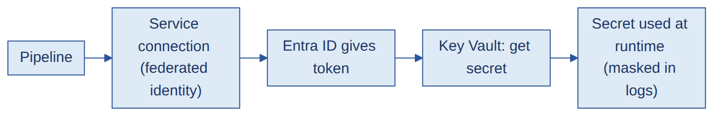

Diagram: Key Vault Private Endpoint ke peeche ho to
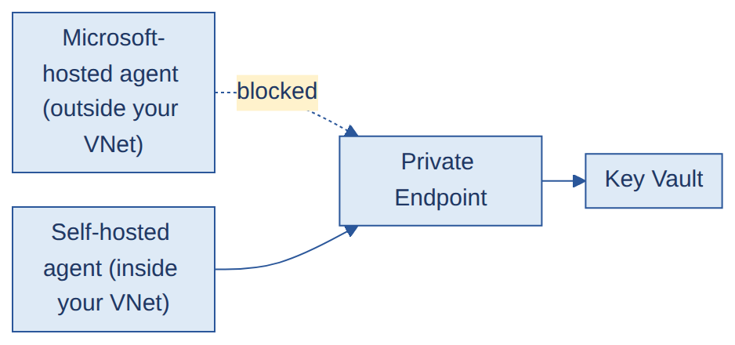

Q&A
Q1. CI/CD mein secrets ko secure kaise karte ho?
A. Key Vault mein store karo, runtime par fetch karo, secret variables (logs mein masked) use karo, least privilege do, aur jahan possible ho client secret ki jagah federated identity.
Q2. Azure DevOps mein Key Vault secret kaise fetch karte ho?
A. Service connection ko vault par get/list permission do, phir AzureKeyVault@2 task ya vault se linked variable group use karo.
Q3. Azure DevOps Key Vault se authenticate kaise karta hai?
A. Service connection ki identity (Service Principal ya federated identity) se, jiske paas vault par role ya access policy hoti hai.
Q4. Key Vault Private Endpoint ke peeche hai. Pipeline kaise reach karegi?
A. Microsoft-hosted agent private endpoint tak nahi pahunch sakta. Isliye VNet ke andar self-hosted agent (ya scale-set agent) use karte hain jo private DNS resolve karke vault tak pahunch sake.
Q5. Client secret vs federated credential?
A. Client secret ek stored password hai jo expire hota hai aur leak ho sakta hai. Federated credential pipeline ke OIDC token par trust karta hai, isliye koi secret store ya rotate nahi karna padta.
Q6. App ko break kiye bina secret rotate kaise karte ho?
A. Versions aur expiry date use karo, app ko Key Vault se latest version read karne do, aur switch-over ke time do valid secrets rakho taaki downtime na ho.
Q7. Hardcoded secrets ko detect aur prevent kaise karte ho?
A. Gitleaks ya TruffleHog code aur commit history scan karte hain. Inhe pre-commit hook aur pipeline ke pehle step mein chalate hain, aur secret mile to build fail kar dete hain.
Q8. Detection par pipeline fail kaise hoti hai?
A. Scanner secret milne par non-zero exit code return karta hai, isse wo step aur poori pipeline fail ho jati hai.
Q9. Passwordless authentication kya hai?
A. Jab identity ko koi password/secret store hi nahi karna padta: Managed Identity ya Workload Identity Federation. Token Azure khud deta hai.
Q10. Service Principal credentials ko secure kaise rakhte ho?
A. Short expiry, secret ki jagah certificate, Key Vault mein storage, least privilege, regular rotation, sign-in monitoring, aur jahan ho sake WIF.
Q11. Service Connection kaise kaam karti hai?
A. Azure DevOps service connection ki identity se Entra ID se token maangta hai, aur us token se Azure Resource Manager ko call karta hai. Permissions identity ke role par depend karti hain.
Q12. Gitleaks/TruffleHog kaise kaam karte hain?
A. Regex rules aur entropy check se files aur Git history scan karte hain. TruffleHog zarurat par secret live hai ya nahi ye bhi verify kar sakta hai.

7. 502 / 503 and other troubleshooting #TROUBLESHOOT DEEP

Samjho
- 502 Bad Gateway: Application Gateway ko backend se galat ya koi response nahi mila.
- 503 Service Unavailable: backend available nahi ya healthy backend hi nahi.
- Approach hamesha layer by layer: DNS → Gateway → Network → Backend → Application.

Diagram: 502 / 503: layer by layer check karo
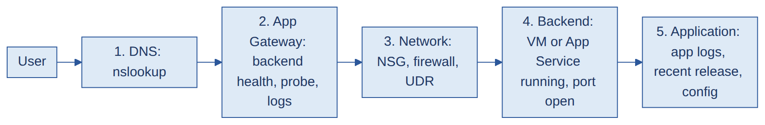

Q&A
Q1. App Gateway 502 de raha hai. Troubleshoot kaise karoge?
A. 1) App Gateway mein backend health (health probe status) dekho. 2) Confirm karo ki backend chal raha hai aur port par listen kar raha hai. 3) Gateway aur backend ke beech NSG aur firewall check karo. 4) Probe path, host header, protocol aur certificate (HTTPS ke liye) dekho. 5) Backend response time gateway timeout se zyada to nahi. 6) Application logs dekho.
Q2. Aur 503 ke liye?
A. Aksar koi healthy backend nahi hota: saare instances probe fail kar rahe hain, backend stopped ya overloaded hai, backend pool galat hai, ya recent deployment ne app tod diya. Main backend pool health dekhta hu, phir app aur server logs.
Q3. Backend theek dikh raha hai par 503 aa raha hai. Aage kya?
A. Health probe settings (path, port, expected status code), backend subnet ke NSG rules, backend pool targets (sahi IP/FQDN), aur gateway se DNS resolution check karo.
Q4. Naye release ke baad 502/503 aa raha hai. Sabse pehle kya karoge?
A. Last release se compare karo: health probe path ya port badla, app start ho rahi hai ya nahi, koi config ya secret missing to nahi. Zarurat ho to pehle previous version par rollback karo, phir investigate karo.
Q5. Users VM par RDP/SSH nahi kar pa rahe. Troubleshoot kaise karoge?
A. VM running hai ya nahi, port 22/3389 ka NSG inbound rule, effective routes aur firewall, Network Watcher (connection troubleshoot / IP flow verify), OS service (sshd/RDP), credentials, aur Bastion use ho raha ho to wo.
Q6. Kaise pata karte ho ki issue DNS, gateway, network ya app ka hai?
A. Resolution test (nslookup), backend ko seedha call karna (VNet ke andar se curl), gateway logs, NSG flow logs, aur application logs. Jo layer pehle fail hoti hai, wahi cause hota hai.
Q7. Terraform state locked hai aur koi kuch run nahi kar pa raha. Kya karoge?
A. Confirm karo koi run active nahi hai, phir terraform force-unlock <LOCK_ID>. Agar failed pipeline se hua ho to state healthy hai ya nahi ye bhi check karo.
Q8. Kisi ne portal se NSG change kar diya. Kya karoge?
A. plan se drift dekho, decide karo ki revert karna hai (apply) ya change rakhna hai (code update), phir portal access restrict karo aur changes pipeline se hi karwao.
Q9. Production deployment succeed hui par application unavailable hai. Kya karoge?
A. App status aur logs, config/secrets/connection strings, DNS aur traffic routing, dependencies (DB), resource limits check karo, previous release se compare karo. Zarurat ho to rollback.
Q10. Deployment Dev mein chalti hai par QA mein fail hoti hai. Troubleshoot kaise karoge?
A. Dono environments ka config (variables, secrets, network rules, versions) compare karo, logs dekho, aur IaC se environments ko standardize karo.
Q11. NSG, Firewall ya Load Balancer ka issue kaise pakadte ho?
A. Network Watcher (IP flow verify), NSG flow logs, Firewall logs (Log Analytics), aur Load Balancer ke health probe status aur metrics.
Q12. Kaise confirm karoge ki issue application code ka hai?
A. Backend ko seedha call karne par bhi error aata hai, app logs mein exceptions hain, ya recent code change ke baad shuru hua. Network layers saaf hon to code hi cause hota hai.
Q13. 503 ke liye backend mein kya check karte ho?
A. Service chal rahi hai, port listen kar raha hai, CPU/memory/disk theek hai, dependencies (DB) up hain, aur app logs.

8. DevSecOps, SAST, DAST, SCA, SonarQube #DEVSECOPS MEDIUM

Samjho
- DevSecOps: security ko CI/CD ke andar shuru se daalna (shift-left), end mein nahi.
- SAST (Static): code ko bina chalaye scan. Jaise SonarQube. Build se pehle/ke saath.
- SCA (Software Composition Analysis): third-party libraries ki known vulnerabilities (Snyk, Dependency-Check).
- DAST (Dynamic): chalti hui application par attack simulate. Jaise OWASP ZAP. Deployed test environment par.
- Quality gate: condition set (jaise coverage ≥ 80%, no critical issues); fail hone par pipeline rukti hai.

Diagram: Security scans pipeline mein kahan lagte hain

Q&A
Q1. What is DevSecOps?
A. Har pipeline stage mein security checks shuru se daalna, taaki issues jaldi milein aur fix karna sasta pade.
Q2. SAST vs DAST vs SCA?
A. SAST source code ko bina chalaye scan karta hai. SCA third-party dependencies ki known vulnerabilities check karta hai. DAST chalti hui application ko bahar se test karta hai, jaise koi attacker karega.
Q3. Ye pipeline mein kahan chalte hain?
A. Secret scan aur SAST code/build stage par, SCA build par (dependencies), container scan image build ke baad, aur DAST test environment mein deploy hone ke baad.
Q4. Har ek kaunsi vulnerabilities pakadta hai?
A. SAST: injection flaws, insecure code patterns, hardcoded secrets. DAST: runtime issues jaise XSS, misconfigurations, missing headers. SCA: vulnerable libraries (CVEs).
Q5. SonarQube kya hai aur kaise kaam karta hai?
A. Ye code mein bugs, vulnerabilities, code smells aur coverage analyze karta hai. Pipeline scanner chalati hai, results SonarQube server ko jaate hain, aur quality gate pass ya fail batata hai.
Q6. Quality Gate kya hai? Coverage 80% se kam ho to pipeline fail kaise karoge?
A. Quality Gate pass/fail conditions ka set hota hai. Main gate mein new code par coverage ≥ 80% set karta hu, aur pipeline step gate ka result wait karta hai aur fail hone par pipeline fail ho jati hai.
Q7. OWASP ZAP kya hai?
A. Ye ek open-source DAST tool hai jo running web app ko crawl aur attack karke XSS aur SQL injection jaisi vulnerabilities dhundta hai.
Q8. SQL injection kya hai aur kaise rokte hain?
A. Attacker ka input SQL query ka hissa ban jata hai. Rokne ke liye parameterized queries, input validation, aur least-privilege DB accounts.
Q9. OWASP Top 10 kya hai?
A. Web application ke 10 sabse critical security risks ki list jo regularly update hoti hai. Testing aur secure coding ke liye baseline ki tarah use hoti hai.
Q10. Security gate critical findings par build fail kar de to kya karoge?
A. Pehle dekho true positive hai ya false positive. Developers ke liye severity aur SLA ke saath ticket banao, fix karke dobara run karo. False positive par documented exception dete hain, bypass nahi.
Q11. Developers security steps ko bypass ya remove na karein, ye kaise rokte ho?
A. Security stages ko shared template mein rakhte hain jise teams extend karti hain, pipeline file ko branch policies aur permissions se protect karte hain, aur checks PR aur production deployment ke liye required rakhte hain.
Q12. CI/CD mein security controls kaise implement karte ho?
A. Layers mein: secret scan, SAST, SCA, IaC scan, image scan, DAST, branch policies, approvals, aur least-privilege access. Har layer pipeline ke alag stage par.
Q13. Security scans ko mandatory kaise banate ho aur gates enforce kaise karte ho?
A. Scans ko shared template mein rakhte hain jise teams extends karti hain, PR par build validation required rakhte hain, aur environment checks se gates enforce karte hain. Gate fail ho to deploy nahi hota.
Q14. Pipeline YAML ko unauthorized modification se kaise protect karte ho?
A. YAML repo par branch policy aur CODEOWNERS, pipeline edit permissions limited, aur security template alag repo mein jise sirf platform/security team badal sake.
Q15. Developer permissions aur pipeline/security permissions alag kaise karte ho?
A. Developers app repo par Contributor hote hain, par security template repo aur pipeline settings par unka write access nahi hota. Wo platform/security team ke paas hota hai.
Q16. Vulnerability remediation ko track kaise karte ho?
A. Scanner findings se ticket automatically banate hain (Azure Boards, Jira ya ServiceNow), severity ke hisaab se SLA (jaise Critical 7 din), aur dashboard se follow-up.
Q17. 100+ applications mein security tools kaise integrate karoge?
A. Ek central shared pipeline template, har app us template ko call kare. Pehle warning mode, phir gradually fail mode. Sirf changed code scan karo aur full scan scheduled rakho.
Q18. Build-time vs runtime security?
A. Build-time: SAST, SCA, IaC aur image scan deploy se pehle. Runtime: WAF, monitoring, Defender, aur chalti application par threat detection/DAST.
Q19. Shift-left security kya hai?
A. Security ko development ke shuru mein lana: pre-commit hooks, PR checks, early scans, aur developers ki training, taaki issues late na milein.
Q20. Kisi ne pipeline ko unauthorized change kiya. Investigate kaise karoge?
A. Git history aur Azure DevOps audit logs dekho: kisne, kab, kya badla. Pipeline run history aur permissions review karo, change revert karo, aur zarurat ho to secrets rotate karo.
Q21. Ek repo mein 10 apps hain aur har commit par saare scans chalte hain, time lagta hai. Kya karoge?
A. Path filters se sirf changed app ka scan, parallel jobs, incremental scans, caching, aur heavy scans nightly ya scheduled.
Q22. SAST vs SCA?
A. SAST apne likhe hue code ko scan karta hai. SCA third-party libraries ki known vulnerabilities (CVEs) dhundta hai.
Q23. SDLC ke kis stage par SAST chalana chahiye?
A. Jitna jaldi ho sake: PR/build stage par, taaki issue developer ko turant dikhe aur fix sasta pade.
Q24. SonarQube kya achieve karta hai aur kaunse reports/metrics deta hai?
A. Code quality aur security: bugs, vulnerabilities, code smells, duplication, coverage, aur technical debt. Quality Gate se pass/fail aur dashboards/reports milte hain.
Q25. OWASP ZAP kaise kaam karta hai aur DAST kahan integrate karte ho?
A. ZAP running app ko spider/crawl karta hai aur attack requests bhejkar vulnerabilities dhundta hai. DAST ko deployed test/staging environment ke baad pipeline mein lagate hain.
Q26. Checkmarx integrate kiya hai?
A. Checkmarx ek SAST tool hai. Pipeline mein uska task/CLI scan chalata hai aur results par gate lagate hain. (Nahi kiya ho to bolo: "Maine SonarQube use kiya hai, Checkmarx ka concept same hai.")

9. VNet, NSG, peering, NAT, LB vs AppGW vs Front Door #NETWORK MEDIUM

Samjho
- VNet = aapka private network Azure mein; subnet = VNet ka hissa. NSG = subnet/NIC par allow/deny rules.
- VNet peering: do VNets ko jodta hai (alag subscription mein bhi ho sakta hai).
- Load Balancer: Layer 4 (TCP/UDP). Application Gateway: Layer 7 (HTTP), URL routing, WAF. Front Door: global Layer 7. Traffic Manager: global, DNS-based.
- NAT Gateway: private VMs ko public IP ke bina outbound internet.

Diagram: Load Balancer vs App Gateway vs Front Door (layers)
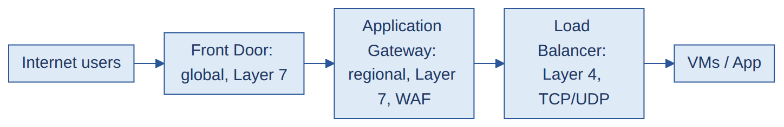

Diagram: VNet peering
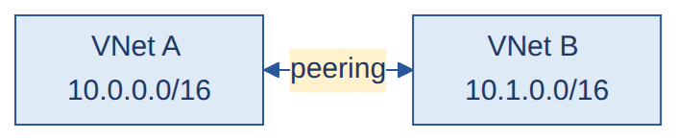

Diagram: Application Gateway ka flow
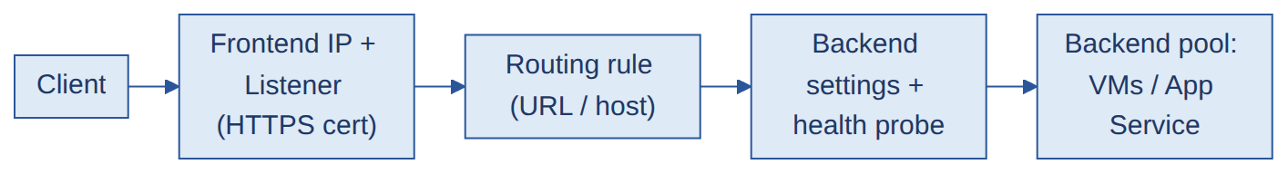

Q&A
Q1. Subnet vs Gateway Subnet?
A. Subnet mein normal resources hote hain. Gateway Subnet ek special subnet hai jiska naam GatewaySubnet hota hai, aur wo sirf VPN/ExpressRoute gateways ke liye reserved hai.
Q2. Do VNets ko kaise connect karte ho? Alag subscriptions mein?
A. VNet peering se. Haan, alag subscription (aur region) mein bhi chalti hai, bas dono side permissions sahi hon aur address spaces overlap na karein.
Q3. Load Balancer vs Application Gateway?
A. Load Balancer Layer 4 par kaam karta hai aur TCP/UDP traffic balance karta hai. Application Gateway Layer 7 par hai, HTTP samajhta hai, aur URL/host routing, SSL termination aur WAF deta hai.
Q4. Application Gateway vs Front Door vs Traffic Manager?
A. Application Gateway regional Layer 7 hai. Front Door global Layer 7 hai (CDN aur WAF ke saath). Traffic Manager global aur sirf DNS-based routing karta hai.
Q5. NSG inbound vs outbound?
A. Inbound rules resource mein aane wale traffic ko control karte hain, outbound rules bahar jane wale traffic ko. Rules priority se evaluate hote hain, sabse kam number pehle.
Q6. NAT Gateway kya hai aur kab use karte ho?
A. Ye private subnet ke resources ko ek static outbound internet IP deta hai, har VM par public IP lagaye bina. Tab kaam aata hai jab VMs ko updates download karne hain par internet se reachable nahi hona chahiye.
Q7. Production VMs par public IP kyun nahi hona chahiye?
A. Isse wo attacks ke liye exposed ho jati hain. Bastion, VPN ya private access use karo, aur public traffic ke liye Load Balancer/App Gateway.
Q8. Vertical vs horizontal scaling?
A. Vertical matlab bada VM (zyada CPU/RAM). Horizontal matlab load balancer ke peeche zyada instances.
Q9. Application Gateway par HTTPS end-to-end kaise configure karte ho?
A. Certificate ke saath HTTPS listener, backend settings HTTPS par backend ke trusted certificate ke saath, sahi host header/SNI, aur NSGs mein port 443 open.
Q10. Dev/Test URLs ko sirf internal users tak kaise restrict karoge?
A. Private listener ya WAF/IP restriction rules, aur NSG rules jo sirf corporate IP ranges allow karein.
Q11. Site-to-Site vs Point-to-Site VPN? Remote employees ko secure access kaise doge?
A. Site-to-Site office/on-prem network ko Azure se jodta hai. Point-to-Site ek individual device ko Azure se jodta hai. Remote employees ke liye Point-to-Site VPN (ya Bastion/AVD) with MFA aur Conditional Access.
Q12. Azure ko on-premises aur doosre cloud se kaise connect karte ho?
A. On-prem ke liye VPN Gateway ya ExpressRoute. Doosre cloud ke liye VPN ya cloud provider ki interconnect service. Bade setups mein Azure Virtual WAN.
Q13. CIDR aur subnet design kaise karte ho?
A. Non-overlapping address spaces (on-prem aur doosre VNets se), future growth ke liye extra room, aur fixed-name subnets ko sahi size (Firewall /26, Bastion /26, Gateway /27).
Q14. Ek Public IP par kitne VMs connect ho sakte hain?
A. Public IP ek hi resource (NIC, Load Balancer, NAT Gateway ya Firewall) par lagta hai. Kai VMs ko share karne ke liye Load Balancer ya NAT Gateway/Firewall ke through, alag ports ya rules se.
Q15. Public IP ke bina outbound internet kaise milta hai?
A. NAT Gateway ya Azure Firewall se (UDR ke saath). Ye explicit outbound path deta hai, aur VM ko directly expose nahi karta.
Q16. HA networking kaise design karte ho?
A. Availability Zones, zone-redundant gateways aur Load Balancer/App Gateway, multiple instances, aur redundant paths (jaise ExpressRoute plus VPN backup).
Q17. Application Gateway kaise kaam karta hai? Frontend IP aur Backend Pool kya hain?
A. Request frontend IP par listener se aati hai, routing rule (URL/host) decide karta hai kahan jana hai, aur backend pool mein targets (VMs, App Service) hote hain. Health probe unki health check karta hai.
Q18. Application Gateway ke subnet ko secure kaise karte ho?
A. Dedicated subnet, NSG mein sirf required ports (jaise 443 aur GatewayManager ke ports), WAF enable, aur backend sirf gateway se traffic le.
Q19. Layer 7 routing aur DNS-based routing mein kya fark hai?
A. Layer 7 (App Gateway/Front Door) HTTP URL ya host dekhkar route karta hai. DNS-based (Traffic Manager) sirf DNS jawab se user ko region/endpoint ki taraf bhejta hai.
Q20. Front Door kab aur kyun use karte ho?
A. Global web apps ke liye: global entry point, CDN, WAF, SSL offload, aur multi-region routing/failover.

10. Private Endpoint and Private DNS #PRIVATE MEDIUM

Samjho
- Private Endpoint: Azure PaaS service (Storage, Key Vault, SQL) ko aapke VNet ke andar ek private IP de deta hai. Traffic internet par nahi jata.
- Private DNS Zone: service ka naam (jaise mystorage.blob.core.windows.net) private IP par resolve karwata hai. Agar DNS galat ho to naam public IP par resolve hota hai aur connection fail.
- Sabse common problem: DNS.

Diagram: Private Endpoint + Private DNS
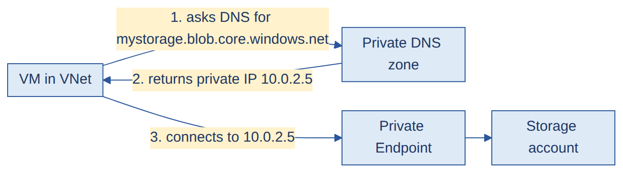

Q&A
Q1. Private Endpoint kya hai aur kaise kaam karta hai?
A. Ye mere subnet mein ek network interface banata hai jiska private IP hota hai aur jo ek specific PaaS resource se connect hota hai. VNet ke clients service tak Microsoft backbone se pahunchte hain, internet se nahi.
Q2. Private DNS Zone ka role kya hai?
A. Wo service ke naam ko private IP par map karta hai. Iske bina clients public IP resolve karte hain.
Q3. DNS ab bhi storage account ko public IP par resolve kar raha hai. Kya galat ho sakta hai?
A. Private DNS zone missing hai, ya VNet se linked nahi hai, ya endpoint ka A record nahi hai, ya VM custom DNS use karta hai jo Azure DNS ko forward nahi karta.
Q4. Change ke baad VM Private Endpoint se Storage tak nahi pahunch pa raha. Troubleshoot kaise karoge?
A. Pehle DNS (nslookup mein private IP aana chahiye). Phir NSG rules, UDRs/firewall jo traffic block ya reroute kar sakte hain, port 443, private endpoint connection status (approved), aur storage ki firewall settings.
Q5. Microsoft-hosted agent Private Endpoint tak kaise pahunchega?
A. Seedha nahi pahunch sakta. VNet ke andar self-hosted agent ya scale-set agent use karo.
Q6. NSG, UDR aur Firewall Private Endpoint connectivity ko kaise affect karte hain?
A. NSG port 443 block kar sakta hai, UDR traffic ko Firewall ki taraf mod sakta hai (jahan rule na ho to drop), aur Firewall rules traffic allow na karein to connection fail hota hai. Isliye teeno check karte hain.
Q7. Port 443 ka troubleshooting kaise karte ho?
A. Test-NetConnection <host> -Port 443 ya nc -zv host 443 chalao, NSG aur Firewall logs dekho, aur DNS sahi private IP de raha hai ye confirm karo.

11. RBAC, Managed Identity, Entra ID, PIM #IDENTITY MEDIUM

Samjho
- RBAC: kaun (user/group/identity) + kya kar sakta hai (role) + kahan (scope: management group, subscription, resource group, resource). Reader, Contributor, Owner common roles.
- Entra ID (pehle Azure AD): Microsoft ki identity service, users, groups, apps ke liye.
- Managed Identity: Azure resource ko automatic identity, bina password ke.
- PIM: privileged access sirf zarurat ke waqt (Just-In-Time), approval ke saath.

Diagram: RBAC = Who + What + Where
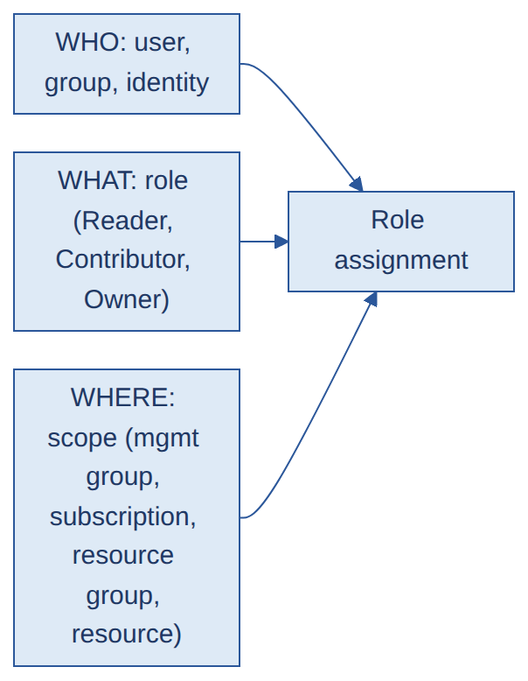

Q&A
Q1. Azure RBAC kya hai?
A. Ye control karta hai ki kaun, kis Azure resource par, kya kar sakta hai. Ye ek scope par role assignment se hota hai.
Q2. RBAC vs Azure Policy?
A. RBAC control karta hai ki kaun kaunse actions kar sakta hai. Policy control karti hai ki kaunse resources ban sakte hain aur unka configuration kaisa hona chahiye, chahe user koi bhi ho.
Q3. Managed Identity vs Service Principal?
A. Managed Identity ko Azure manage karta hai aur usme secret nahi hota. Service Principal ek app identity hai jisme secret ya certificate hota hai jise mujhe rotate karna padta hai.
Q4. Microsoft Entra ID kya hai?
A. Microsoft ki cloud identity aur access service. Ye users, groups, apps aur sign-in (MFA aur Conditional Access ke saath) manage karti hai.
Q5. Static vs dynamic group?
A. Static group mein members manually add hote hain. Dynamic group mein membership user attributes ke rules se automatically decide hoti hai.
Q6. PIM kya hai?
A. Privileged Identity Management eligible users ko just-in-time aur time-limited privileged roles deta hai, approval aur audit ke saath.
Q7. Least privilege kaise implement karte ho?
A. Sabse chhote scope par sabse kam role do, individuals ki jagah groups use karo, aur access ko regularly review karo.
Q8. Naya developer join kare to kya access doge?
A. Use sahi Entra group mein add karo, zarurat ke hisaab se resource group scope par Reader ya Contributor do, aur repo, project aur pipelines ka access do.
Q9. Contributor access hai par Blob par "access denied" aa raha hai. Kyun?
A. Contributor management-plane role hai. Blob data access ke liye data-plane role chahiye, jaise Storage Blob Data Reader/Contributor.
Q10. Landing Zone mein IAM aur RBAC kaise implement karte ho?
A. Entra ID groups banate hain, group ko role assign karte hain management group/subscription/resource group scope par, aur least privilege rakhte hain.
Q11. CI/CD mein RBAC kaise implement karte ho? Deployment failures kaise rokta hai?
A. Service connection ko sirf zaroori scope par sirf zaroori role (jaise ek RG par Contributor). Isse accidental/unauthorized changes aur "permission denied" surprises kam hote hain.
Q12. Eligible/Just-In-Time access kaise implement karte ho?
A. PIM se privileged role "eligible" rakhte hain. User zarurat par activate karta hai (approval aur justification ke saath), aur role time ke baad khud hat jata hai.
Q13. Service Principal ko secure kaise karte ho?
A. Short-lived credentials ya certificates, least privilege, secrets Key Vault mein, aur jahan possible ho Managed Identity ya WIF.
Q14. Domain Admin vs Enterprise Admin?
A. Domain Admin ek domain ko control karta hai. Enterprise Admin poore AD forest (saare domains) ko.
Q15. Kuch users ko MFA se exclude kaise karte ho?
A. Conditional Access policy mein "All users" include karo aur ek specific group exclude karo (ya trusted named location). Exclusions ko regularly review karna chahiye.

12. VM access, Bastion, SSH, Linux tasks #VM-LINUX MEDIUM

Samjho
- Secure VM access: public IP ki jagah Azure Bastion (browser se RDP/SSH), VPN, ya JIT access.
- SSH key authentication: public key VM par (~/.ssh/authorized_keys), private key aapke paas. VM challenge deti hai, sirf private key wala hi solve kar sakta hai.
- Linux tasks mein commands aati honi chahiye.

Diagram: Bastion se secure access
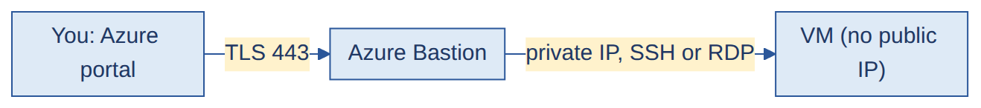

Diagram: SSH key authentication
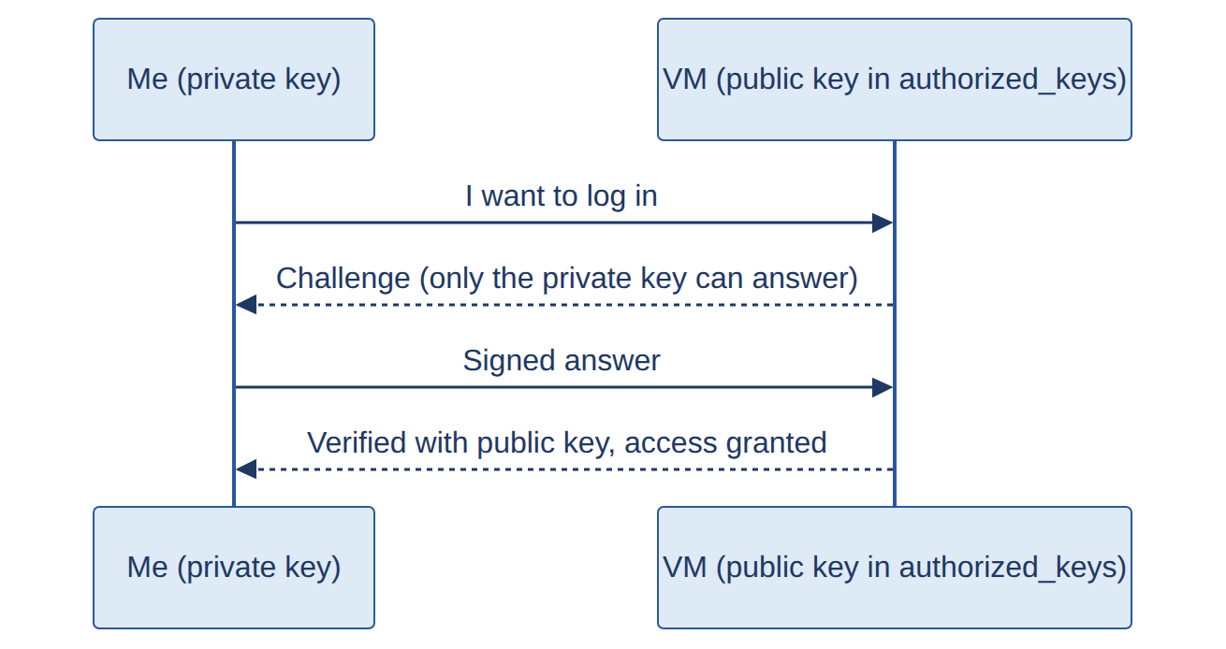

Q&A
Q1. VM ko securely access kaise karte ho?
A. Azure Bastion, VPN ya ExpressRoute, ya Just-In-Time access. Public IP nahi aur internet par RDP/SSH open nahi.
Q2. Azure Bastion kya hai?
A. Ek managed service jo Azure portal se TLS par VM ka RDP/SSH deti hai, sirf VM ke private IP se.
Q3. SSH key authentication kaise kaam karta hai?
A. Public key server par store hoti hai, private key mere paas rehti hai. Server ek challenge bhejta hai jiska jawab sirf matching private key de sakti hai, isliye password network par nahi jata.
Q4. Do keys kyun?
A. Public key freely share ho sakti hai aur sirf verify karti hai. Private key secret hoti hai aur identity prove karti hai, isliye public key share karna safe hai.
Q5. Keys kahan store hoti hain?
A. Public key server par ~/.ssh/authorized_keys mein, private key mere machine par ~/.ssh/ mein.
Q6. SSH port kaise change karte ho?
A. /etc/ssh/sshd_config mein Port 2222 likho, NSG aur firewall mein naya port allow karo, sshd restart karo, aur ssh -p 2222 user@host se connect karo.
Q7. SSH connectivity troubleshoot kaise karte ho?
A. VM status, port ka NSG rule, effective routes aur firewall, sshd service status, key permissions aur username, aur auth log (/var/log/auth.log).
Q8. Linux ka root disk full hai. Disk add karke extend kaise karoge?
A. Azure mein managed data disk add karo, phir VM par: lsblk se disk dekho, partition banao (fdisk ya parted), pvcreate, vgextend, lvextend -r -l +100%FREE /dev/<vg>/<lv> (-r filesystem bhi resize karta hai), aur df -h se verify karo.
Q9. VM par high CPU hai. Kaunse tools use karoge?
A. Azure Monitor metrics, VM Insights aur Log Analytics se trend dekhta hu, phir VM ke andar top ya htop se process dhundta hu.
Q10. 10 ya 100 VMs ko bina har ek ko chhue patch kaise karoge?
A. Azure Update Manager (scheduled patching), Automation, ya Ansible jaisa configuration tool.
Q11. Dev VM roz raat ko shutdown hoti hai par phir bhi bill aa raha hai. Kyun?
A. OS ke andar se shutdown karne par VM allocated rehti hai. Use Azure se Stop (deallocate) karna padta hai. Saath mein disks aur public IPs ka cost bhi lagta hai.
Q12. SSH ke liye port 22 hi kyun?
A. Ye SSH ka standard default port hai (IANA assigned). Chahein to sshd_config mein badal sakte hain.
Q13. Bastion aur Production VM ke beech communication secure kaise karte ho?
A. Bastion ke subnet se VM ke private IP par, NSG mein sirf Bastion subnet se 22/3389 allow, VM par public IP nahi, aur Bastion access Entra ID RBAC aur MFA se.
Q14. Azure Automation Account vs Update Manager?
A. Update Manager patch assessment aur scheduling ke liye hai. Automation Account runbooks (scripts) chalane ke liye hai, jisse custom automation hota hai.
Q15. AVD mein Pooled vs Personal host pool?
A. Pooled: kai users ek hi session hosts share karte hain (cost-efficient). Personal: har user ko apna dedicated VM milta hai.

13. Docker basics #DOCKER MEDIUM

Samjho
- Image = application ka package (read-only template); container = image ka running instance; registry = images ki storage (ACR, Docker Hub).
- Dockerfile = image banane ke steps.
- Multi-stage build: pehle stage mein build, last stage mein sirf zaroori output. Image chhoti aur secure.
# Simple example (Node app)
FROM node:20-alpine
WORKDIR /app
COPY package*.json ./
RUN npm install --production
COPY . .
EXPOSE 3000
CMD ["node", "server.js"]

# Multi-stage example (Java)
FROM maven:3.9-eclipse-temurin-17 AS build
WORKDIR /src
COPY . .
RUN mvn -q package -DskipTests

FROM eclipse-temurin:17-jre
COPY --from=build /src/target/app.jar /app/app.jar
CMD ["java", "-jar", "/app/app.jar"]

Diagram: Docker flow

Diagram: Multi-stage build
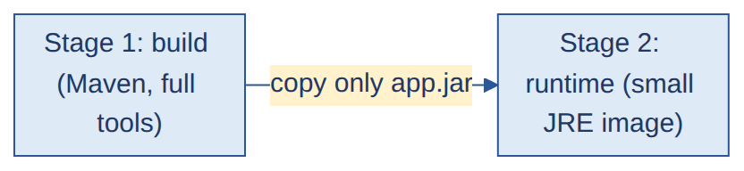

Q&A
Q1. Dockerfile kaise banate ho?
A. FROM se base image chuno, WORKDIR set karo, pehle dependency files copy karke install karo, phir code copy karo, EXPOSE se port batao, aur CMD set karo. Dependencies pehle copy karne se layer caching ka fayda milta hai.
Q2. Multi-stage build kya hai?
A. Ek Dockerfile mein kai stages: pehle stage mein build, aur final artifact ko chhote runtime image mein copy. Isse image size aur attack surface kam hota hai.
Q3. `docker build` vs `docker commit`?
A. docker build Dockerfile se image banata hai, jo repeatable hai. docker commit chalte container ki current state se image banata hai, jo repeatable nahi hai aur recommended nahi hai.
Q4. Image ko scan kaise karte ho?
A. Pipeline mein image build ke baad Trivy jaisa scanner chalate hain, aur high ya critical findings par build fail kar dete hain.
Q5. Production image mein critical vulnerability mili. Kya karoge?
A. Dekho exploitable hai ya nahi, base image ya package update karo, rebuild aur rescan karo, aur pipeline se redeploy karo. Fix ready na ho to temporary mitigation lagao.
Q6. 100 Java microservices ke liye ek base image kaise manage karoge? Java 11 se 17?
A. Registry mein ek approved base image rakho jise sab services FROM mein use karein. Pehle POC mein Java 17 test karo, naya base image tag publish karo, aur pipeline se services ko batches mein roll out karo (Renovate ya Dependabot se automate ho sakta hai). Rollback ke liye purana tag rakho.
Q7. Container images ko secure kaise karte ho?
A. Chhota trusted base image, multi-stage build, non-root user, image scan (Trivy), secrets image mein nahi, aur registry mein sirf approved images.

14. Git and branching #GIT MEDIUM

Diagram: PR flow
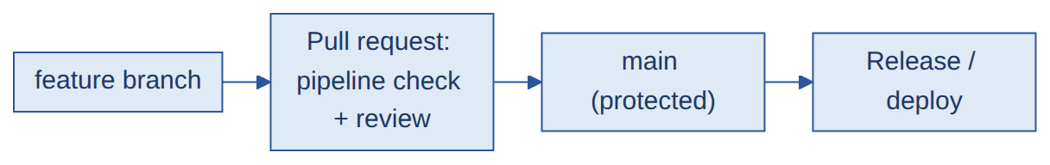

Q&A
Q1. Apni branching strategy batao.
A. main (ya develop) se feature branches banate hain, pull request mein review aur pipeline validation hota hai, phir merge. Release branches ya tags production versions ko mark karte hain.
Q2. `main` ko protect kaise karte ho?
A. Branch policies: direct push band, PR required, minimum reviewers, required build validation, aur comments resolve.
Q3. Merge vs rebase?
A. Merge poori history rakhta hai aur ek merge commit banata hai. Rebase commits ko target branch ke upar replay karta hai, jisse history linear rehti hai.
Q4. Merge conflict kaise resolve karte ho?
A. Conflict wali files kholo, sahi changes chuno, git add karo, phir commit karo (ya rebase continue karo).
Q5. Feature se integration se main tak flow kaise implement karte ho?
A. Feature branch se develop (integration) mein PR, pipeline tests aur review, phir develop se main mein release PR. main par sirf PR se merge.
Q6. Infra aur application repos alag rakhte ho ya saath?
A. Alag repos: independent access, release cycle aur ownership. Monorepo: ek jagah sab, cross-changes aasaan. Choice team size aur ownership par depend karti hai.
Q7. GitHub branch protection rules kaise secure karte hain?
A. Direct push block, PR aur reviews required, status checks (pipeline) required, force push block, aur signed commits (optional).

15. Azure Monitor, alerts, New Relic #MONITOR MEDIUM

Samjho
- Azure Monitor metrics aur logs collect karta hai. Log Analytics Workspace mein logs store hote hain, KQL se query karte ho.
- Alert rule: condition (threshold) + action group (email/Teams/ticket).
- Noisy alert problem: thresholds galat, duplicate alerts, ya flapping.

Diagram: Azure Monitor flow
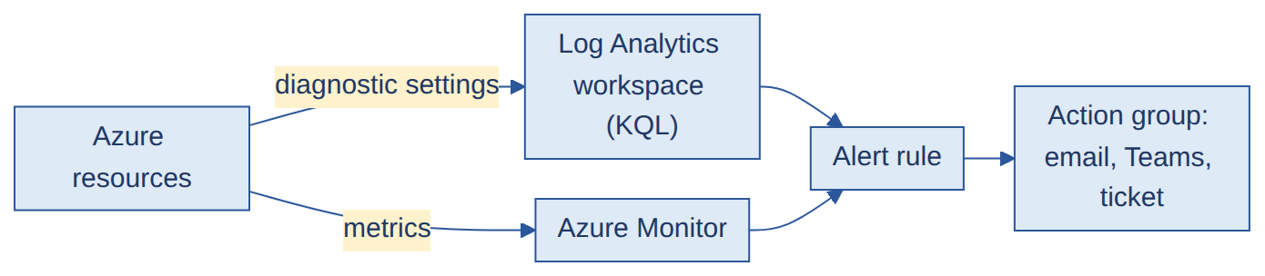

Q&A
Q1. Azure Monitor kaise kaam karta hai?
A. Resources metrics aur logs Azure Monitor ko bhejte hain (diagnostic settings ya agents se). Metrics near real-time hote hain, aur logs Log Analytics workspace mein jaate hain jahan KQL se query karte hain.
Q2. Log Analytics Workspace kya hai?
A. Logs ka central store jahan query, retention aur alerting hoti hai. Retention decide karta hai ki logs kitne purane tak dekh sakte hain.
Q3. Alert kaise banate ho?
A. Resource aur signal chuno (jaise CPU > 80% for 5 minutes), severity set karo, aur action group attach karo jo team ko notify kare.
Q4. Bahut noisy false-positive alerts aa rahe hain. Kaise fix karoge?
A. Noisy rules dhundo, thresholds ko normal behavior se compare karo, evaluation window badhao, dynamic thresholds use karo, duplicates hatao, alerts ko group karo, aur regularly review karo.
Q5. Aap kya monitor karte ho?
A. CPU, memory, disk, availability, response time, error rate, aur pipelines ke liye failure rate.
Q6. Kaunse monitoring tools use kiye hain? End-to-end monitoring kaise set karte ho?
A. Azure Monitor, Log Analytics, aur Application Insights/New Relic jo aapne use kiya ho wahi bolo. Setup: diagnostic settings/agents se logs aur metrics, dashboards, alerts, aur action groups. VM ke liye VM Insights.
Q7. Observability kya hai?
A. System ko metrics, logs aur traces se samajhna, taaki problem ka kaaran dhundh sako, sirf "kuch fail hua" nahi.
Q8. KPIs aur thresholds kaunse set karte ho?
A. Availability, response time/latency, error rate, CPU/memory/disk, queue length. Thresholds normal baseline se decide hote hain (jaise CPU > 80% for 5 min).
Q9. Latency aur Error dashboards mein kya rakhoge?
A. Latency: P50/P95/P99 response time, slowest endpoints. Error: 4xx/5xx rate, top failing endpoints, exceptions aur recent deployments ke saath correlation.
Q10. P50, P95, P99 kya hain?
A. Percentiles. P50 median (typical user), P95 means 95% requests usse tez the, P99 worst-case tail dikhata hai. Averages slow outliers chhupa dete hain.
Q11. Alerting strategy kaise design karte ho? Genuine vs duplicate alerts?
A. Severity levels, actionable alerts, alerts group karna, aur duplicates dedupe. Genuine alert mein user impact/threshold breach hota hai, duplicate mein ek hi root cause ke kai alerts.
Q12. Azure Monitor vs New Relic?
A. Azure Monitor Azure-native hai aur Azure resources ke saath gehra integrate hota hai. New Relic third-party hai, multi-cloud aur strong APM/dashboards deta hai.
Q13. New Relic application logs tak kaise pahunchta hai? Logs kahan store hote hain, retention?
A. Agent ya log forwarder app/host par chalta hai aur logs/metrics New Relic ko bhejta hai, jahan wo platform mein store hote hain. Retention plan aur setting par depend karti hai (jaise 3 din purane logs dekhne ke liye retention kam se kam utni ho).

16. Landing Zone, Hub-and-Spoke, Firewall + UDR #LZ MEDIUM
IMPORTANT Aapki shared image isi section ka base hai. Ye topic 4 mahine ke profile par deep nahi poochha jaata, par Cognizant, TCS, KPMG, Publicis sab mein aata hai, isliye yahan poora flow samjha diya hai: structure → network → traffic flow → build order → Q&A.

Samjho
- Landing Zone = Azure mein ek pehle se taiyar, governed foundation. Management Groups, Subscriptions, Networking, Identity, Policy, Monitoring sab ek planned structure mein.
- Hub-and-Spoke = network ka design. Hub mein shared/security cheezein (Firewall, Bastion, Gateway, DNS). Spokes mein apps (VMs, Web App, Functions). Har spoke hub se peer hota hai.
- Peering transitive nahi hota: Spoke1 ↔ Hub aur Spoke2 ↔ Hub peering hai, to bhi Spoke1 aur Spoke2 seedha baat nahi kar sakte. Beech mein Firewall + UDR lagana padta hai. (Interview ka favourite point.)

Diagram: Aapki image ka structure (Tenant se Spokes tak)
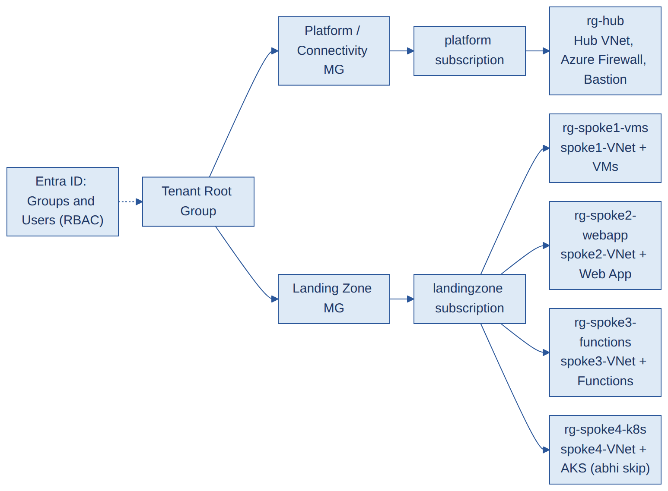

Diagram: Har spoke Hub se peer hota hai
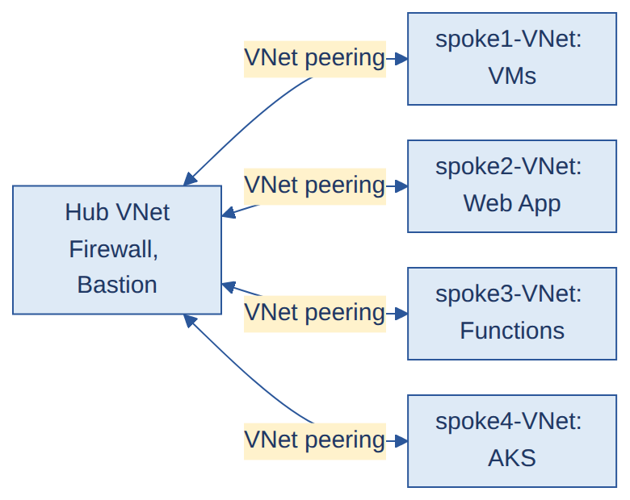
Image kaise padhni hai (interview mein bolne ke liye):
- Sabse upar Tenant Root Group. Uske neeche do Management Groups: Platform/Connectivity aur Landing Zone.
- Platform MG ke andar platform subscription hai, jisme rg-hub resource group hai. Isme Hub VNet, Azure Firewall aur Bastion hain.
- Landing Zone MG ke andar landingzone subscription hai, jisme har app ke liye alag resource group aur alag spoke VNet hai: VMs, Web App, Functions, AKS.
- Har spoke ka VNet peering Hub se hai. Governance (policy) MG se neeche aata hai, access Entra ID groups se (RBAC) milta hai.

Diagram: Hub-and-Spoke network (andar kya-kya hai)
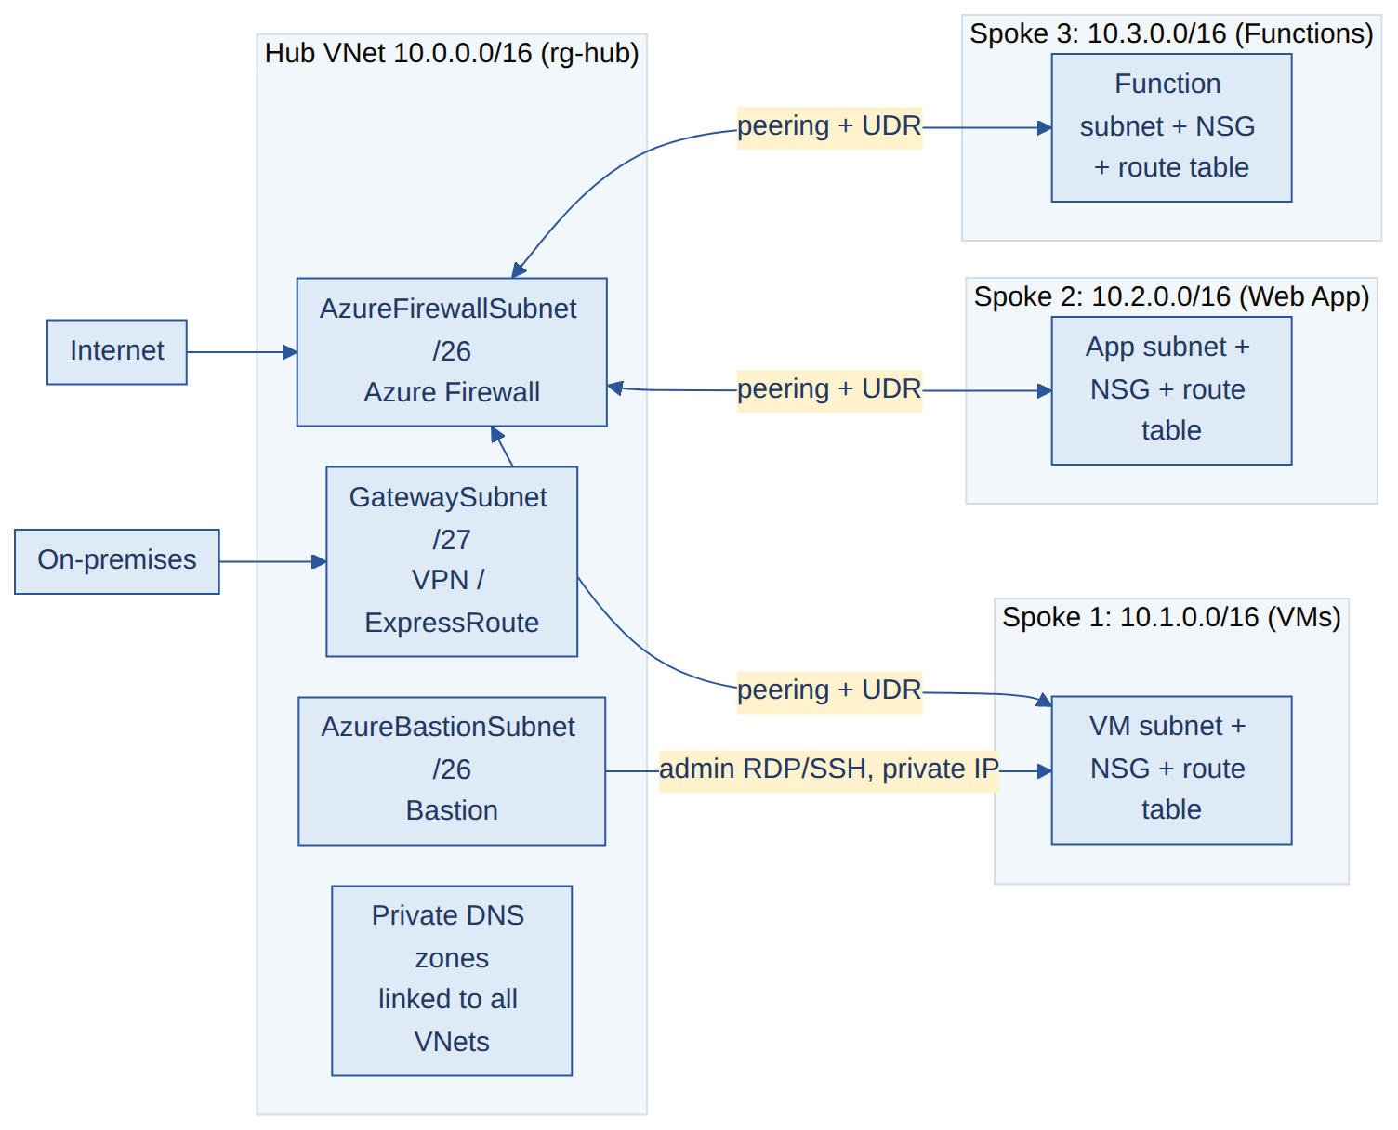
Example IP plan (overlap nahi hona chahiye, warna peering nahi banti):
Network | CIDR | Special subnets
Hub VNet | 10.0.0.0/16 | AzureFirewallSubnet /26, AzureBastionSubnet /26, GatewaySubnet /27
Spoke1 (VMs) | 10.1.0.0/16 | workload subnet
Spoke2 (Web App) | 10.2.0.0/16 | app subnet
Spoke3 (Functions) | 10.3.0.0/16 | function subnet
Spoke4 (AKS) | 10.4.0.0/16 | abhi skip

Ye naam fixed hain: `AzureFirewallSubnet`, `AzureBastionSubnet`, `GatewaySubnet`. Inhe change nahi kar sakte.

Hub mein kya aur kyun
Component | Kaam
Azure Firewall | Saara inbound/outbound/spoke-to-spoke traffic yahin se guzarta hai. Network aur application rules, logging.
Azure Bastion | Browser se secure RDP/SSH, VMs par public IP ki zarurat nahi.
VPN / ExpressRoute Gateway | On-premises se connection.
Private DNS zones | Private Endpoint ke names ko private IP par resolve karwate hain.
Log Analytics / Monitoring | Firewall aur network logs ka central point.

Diagram: Traffic flows
(a) Outbound (VM se internet) forced through Firewall
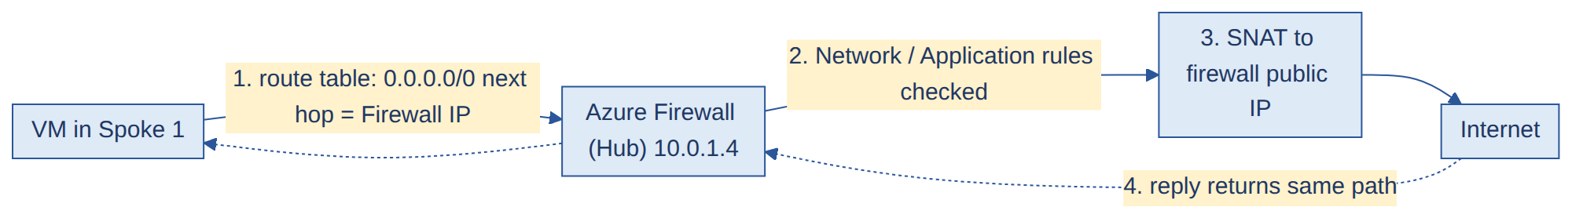
(b) Spoke-to-spoke (peering transitive nahi, isliye Firewall beech mein)
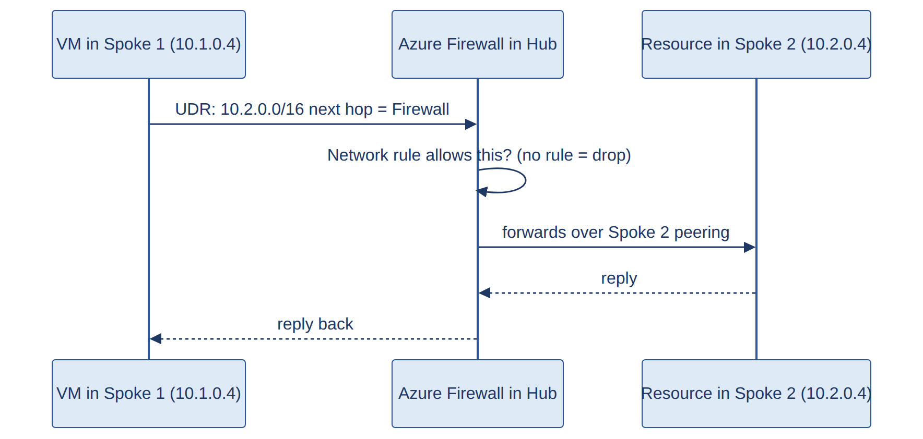
(c) Internet se Web App (inbound)
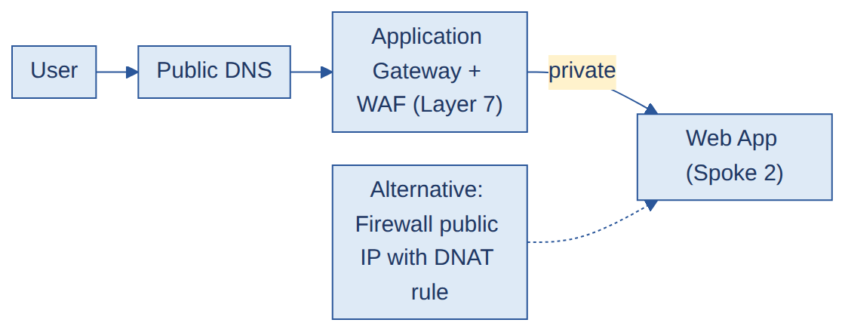
(d) Admin access (Bastion)
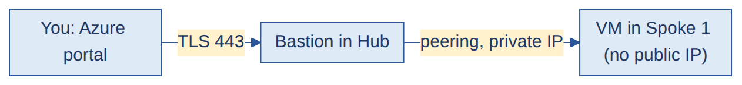

Peering aur UDR ki settings (yaad rakho)
Cheez | Setting
Peering | Dono taraf banani padti hai: Hub→Spoke aur Spoke→Hub
Allow forwarded traffic | Dono sides ON (nahi to Firewall se forwarded traffic drop hota hai)
Gateway transit | Hub side Allow gateway transit, spoke side Use remote gateway (jab gateway ho)
Route table (spokes par) | 0.0.0.0/0 → next hop type Virtual Appliance → Firewall ka private IP
Spoke-to-spoke route | 10.x.0.0/16 of other spoke → Virtual Appliance → Firewall IP
Route table kahan lagti hai | Spoke ke workload subnets par. Firewall ke apne subnet par nahi
Firewall rules | Default deny. Jo traffic allow karna hai wahi rule se kholo

Governance aur access (image mein upar/side mein jo hai)
- Management Groups: Platform MG aur Landing Zone MG par alag Azure Policies (jaise allowed regions, mandatory tags).
- RBAC with Entra ID groups: user ko direct role nahi, group ko role. Jaise grp-platform-admins → Contributor on rg-hub; grp-app1-devs → Contributor on rg-spoke1-vms; sab ke liye Reader group.
- Subscriptions alag kyun: platform (shared, critical) aur landing zone (apps) ko alag rakhne se access, cost aur blast radius alag rehta hai.

Build order (Terraform mein kis order mein banate hain)
- Management Groups aur subscriptions place karo
- rg-hub, Hub VNet aur 3 special subnets
- Azure Firewall (public IP + firewall policy)
- Bastion (public IP)
- Spoke resource groups aur Spoke VNets (non-overlapping CIDR)
- Peerings (dono directions)
- Route tables (UDR) + subnet associations, NSGs
- Private DNS zones (VNets se link)
- Workloads (VMs, Web App, Functions)
- Entra groups, RBAC, Policies
landing-zone/
├── modules/
│ ├── hub-network/ # vnet, subnets
│ ├── firewall/ # firewall + policy + pip
│ ├── bastion/
│ ├── spoke-network/ # vnet, nsg, route table
│ └── peering/ # both directions
└── envs/
└── prod/
├── main.tf # calls modules in order
├── variables.tf
├── terraform.tfvars
└── backend.tf # remote state (Azure Blob)

Q&A
Q1. Apna Hub-and-Spoke architecture explain karo.
A. Hamare paas ek Hub VNet hai jisme shared services hain: Azure Firewall, Bastion, aur zarurat ho to VPN/ExpressRoute gateway aur Private DNS. Har application ka alag Spoke VNet hai (VMs, Web App, Functions), jo Hub se peer hota hai. Saara outbound aur spoke-to-spoke traffic UDR se Firewall ke through jaata hai. (Agar aapne production mein nahi banaya: "Maine ise lab mein banaya hai aur flow ye hai...")
Q2. Hub mein kaunse resources hote hain?
A. Azure Firewall, Bastion, VPN/ExpressRoute gateway, aur Private DNS zones. Ye saare shared resources hain jo har spoke ko chahiye.
Q3. Hub-and-Spoke kyun? Advantage kya hai?
A. Security aur shared services ek jagah centralize ho jaate hain, to har VNet mein alag firewall/bastion nahi banana padta. Isse cost bachti hai, policy ek jagah lagti hai, aur spokes isolated rehte hain.
Q4. Spokes ko kaise segregate karte ho?
A. Application ya environment ke hisaab se: har app/workload ka apna spoke VNet aur resource group, taaki network, access (RBAC) aur cost alag rahein. Prod aur non-prod ko alag subscription ya alag spokes mein rakhte hain.
Q5. Peering transitive hai? Spoke1 Spoke2 se baat kaise karega?
A. Peering transitive nahi hai. Spoke1 aur Spoke2 dono Hub se peer hain, par aapas mein nahi. Isliye har spoke mein UDR lagate hain jo doosre spoke ke traffic ko Hub ke Azure Firewall ko bhejta hai, aur Firewall rule allow kare to forward ho jaata hai.
Q6. Spoke se internet jaane ka poora flow batao.
A. VM → subnet ki route table (0.0.0.0/0 next hop Firewall) → peering se Hub → Azure Firewall (rules check, SNAT) → internet. Reply usi raste se wapas aata hai.
Q7. Internet se spoke ki app tak ingress flow?
A. User → DNS → Application Gateway (WAF) ya Firewall ka public IP (DNAT) → spoke ka Web App/VM. HTTP/HTTPS apps ke liye Application Gateway ya Front Door, aur baaki traffic ke liye Firewall DNAT.
Q8. UDR ko kahan associate karte ho aur kyun?
A. Spoke ke workload subnets par, taaki unka traffic Firewall se guzare. Firewall ke apne subnet par default internet route hi rehta hai.
Q9. Peering ki important settings kaunsi hain?
A. Dono directions mein peering banao, Allow forwarded traffic ON rakho (Firewall se aaya traffic accept karne ke liye), aur gateway ho to hub par Allow gateway transit aur spoke par Use remote gateway.
Q10. Bastion se spoke ke VMs kaise access hote hain?
A. Bastion Hub mein hota hai aur peering ke through spokes ke VMs ke private IP tak pahunchta hai. VMs par public IP nahi lagta.
Q11. Private Endpoint ke DNS ka kya?
A. Private DNS zones ko Hub (aur zarurat ke hisaab se spokes) se link karte hain, taaki sab VNets service ka naam private IP par resolve karein.
Q12. Pura Landing Zone ek click mein kaise deploy karoge?
A. Har cheez ke liye alag Terraform module (hub network, firewall, bastion, spoke, peering), ek root module jo unhe sahi order mein call kare, outputs/inputs se values pass ho, aur ek pipeline jo plan aur approval ke baad apply chalaye.
Q13. Multiple subscriptions mein Terraform kaise chalate ho?
A. Har subscription ke liye alag provider block (alias ke saath) ya alag pipeline stage, authentication ek service connection/Service Principal se jisko dono subscriptions par role mila ho. Remote state ek central storage account mein, har environment ki alag key ke saath.
Q14. Platform vs application landing zone?
A. Platform landing zone mein shared services hain (connectivity, identity, management), aur application landing zone mein workloads. Aapki image mein platform subscription = Hub, landingzone subscription = spokes.
Q15. Landing Zone mein governance kaise lagti hai?
A. Management Groups par Azure Policies (allowed regions, mandatory tags, public IP deny), aur RBAC Entra groups se. Policy upar se neeche inherit hoti hai.
Q16. Azure Landing Zone zero se kaise design karoge?
A. Pehle requirements aur governance, phir Management Group hierarchy aur subscriptions, identity (Entra ID aur RBAC), network topology (Hub-and-Spoke), policies, security aur monitoring. Poora kaam Terraform/pipeline se, CAF (Cloud Adoption Framework) ke guidance ke saath.
Q17. Landing Zones ke types kaunse hain?
A. Platform landing zone (connectivity, identity, management) aur application landing zones (workloads). Application zones corp (private) ya online (internet-facing) ho sakte hain.
Q18. Hub-and-Spoke ke alawa Landing Zone mein aur kya hota hai?
A. Management Groups aur subscriptions, Azure Policy, RBAC/identity, monitoring (Log Analytics), security (Defender for Cloud), aur backup/DR.
Q19. Existing Landing Zone mein naya application kaise onboard karte ho?
A. Naya subscription ya resource group, ek spoke VNet (non-overlapping CIDR), hub se peering, route table (UDR) aur NSG, RBAC groups, policies inherit, aur monitoring/diagnostics. Sab Terraform module aur pipeline se.
Q20. Multi-region Landing Zone kaise design karoge?
A. Har region mein ek hub, doosre region mein DR, global identity (Entra ID), regions ke beech hub peering, aur Traffic Manager/Front Door global routing ke liye. DR aur policies dono regions mein.
Q21. VNet peering ki limits kya hain? Hazaaron VNets ke liye kya karoge?
A. Har VNet par peerings ki ek limit hoti hai (kuch hundred). Bahut bade environments mein Azure Virtual WAN use karte hain, jo hub connectivity ko managed aur scalable bana deta hai.
Q22. Platform-engineering ke nazariye se Landing Zone ko secure kaise karte ho?
A. Policy guardrails (allowed regions, deny public IP, mandatory tags), centralized Firewall aur logging, least-privilege RBAC aur PIM, Defender for Cloud, aur pipelines ke through hi changes.
Q23. Azure Firewall implement karte waqt best practices kaunsi hain?
A. Default deny, Firewall Policy se rules manage karna, application aur network rules alag, logging Log Analytics mein, zone-redundant deployment, aur rules ko Terraform se version-control karna.
Q24. Firewall se poora packet flow samjhao.
A. Source VM → subnet route table (UDR) → Firewall ka private IP → rules check → (SNAT) → destination. Reply wapas Firewall se source tak. Spoke-to-spoke mein dono spokes ke UDR Firewall ko point karte hain.
Q25. Azure custom routes ko system routes par prefer kaise karta hai?
A. Same prefix par user-defined routes system routes se upar aate hain. Pehle sabse specific prefix (longest match), phir UDR, BGP, system.
Q26. Internet-facing app ko Firewall se kaise secure karte ho aur backend ko direct exposure se kaise bachate ho?
A. Inbound ke liye Firewall DNAT ya Application Gateway (WAF), backend VMs par public IP nahi, NSG se sirf gateway/Firewall se traffic allow, aur outbound Firewall se.

17. Azure Policy and governance #POLICY CONCEPT

Samjho
- Azure Policy rules lagata hai ki kaunse resources bana sakte ho (jaise sirf Central India, tags mandatory, public IP nahi).
- Hierarchy: Definition (rule) → Initiative (rules ka group) → Assignment (scope par lagana) → Remediation (non-compliant ko theek karna).
- Effects: Audit (sirf report), Deny (rok deta hai), Modify (badal deta hai, jaise tag add), DeployIfNotExists (kuch missing ho to bana deta hai).

Diagram: Policy hierarchy
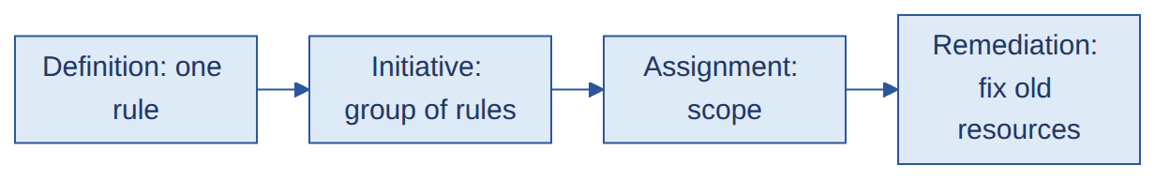

Q&A
Q1. Azure Policy kya hai?
A. Ek service jo resources par organization ke rules enforce karti hai aur compliance report karti hai.
Q2. Policy hierarchy samjhao.
A. Definition mein rule hota hai, initiative kai definitions ko group karta hai, assignment use ek scope par lagata hai, aur remediation existing non-compliant resources ko fix karta hai.
Q3. Audit vs Deny vs Modify vs DeployIfNotExists?
A. Audit sirf flag karta hai. Deny request ko block karta hai. Modify properties badalta hai, jaise tag add karna. DeployIfNotExists koi related resource missing ho to deploy kar deta hai, jaise diagnostic settings.
Q4. Policy kin scopes par assign hoti hai?
A. Management group, subscription, resource group.
Q5. Deployments ko specific regions tak kaise restrict karoge?
A. Built-in "Allowed locations" policy ko approved regions ke saath management group ya subscription scope par assign karo.
Q6. Public IP creation block ya tags mandatory kaise karoge?
A. Public IP resource type par Deny policy; tags ke liye Deny policy (tag required) ya Modify policy (tag add kar do).
Q7. Accidental deletion kaise rokoge?
A. Resource locks (CanNotDelete) aur limited RBAC se. Policy mostly configuration rules ke liye hai, delete protection ke liye nahi.
Q8. Built-in vs custom policy?
A. Built-in Microsoft ne ready banayi hoti hai (jaise Allowed locations). Custom policy tab banate hain jab apni specific requirement ke liye built-in na ho.
Q9. Policy Initiative kya hai?
A. Kai policy definitions ka group, taaki ek saath assign aur manage ho sake (jaise ek "Security baseline").
Q10. Custom policy kaise banate ho? Region restrict karne ka example.
A. JSON mein rule likhte hain. Example:
{
"mode": "All",
"policyRule": {
"if": { "not": { "field": "location", "in": ["centralindia", "southindia"] } },
"then": { "effect": "deny" }
}
}

Q11. Policy definition ke main fields aur condition logic kaise kaam karta hai?
A. Fields: displayName, mode, parameters, aur policyRule (if condition aur then effect). if mein field/value ko operators (equals, in, not, allOf/anyOf) se check karte hain, aur match par effect (Deny, Audit, Modify, ...) lagta hai.
Q12. Policy ko Terraform se kaise automate karte ho? Policy as Code kya hai?
A. azurerm_policy_definition, azurerm_policy_set_definition aur azurerm_management_group_policy_assignment resources se. Policy as Code matlab policies Git mein rakhna, PR se review, aur pipeline se deploy, taaki versioned aur consistent rahein.
Q13. Policy changes ko PR aur CI/CD se kaise validate aur deploy karte ho?
A. PR mein policy JSON/Terraform review, pipeline mein validate aur plan, pehle Audit mode mein Dev par test, phir approval ke baad Prod. Compliance report se verify.
Q14. Non-compliant resources ko automatically kaise remediate karte ho?
A. Modify ya DeployIfNotExists effect se, jo managed identity ke saath remediation task chalakar existing resources ko theek karta hai.

18. Software supply chain, SBOM, vulnerabilities #SUPPLY CONCEPT

Samjho
- Supply chain attack: attacker aapke code par nahi, aapke dependencies, build tools ya packages par hamla karta hai, jo trusted source se aapke software mein aa jata hai.
- SBOM (Software Bill of Materials): application ke saare components aur versions ki list. Naya CVE aaye to turant pata chal jata hai kaun si app affected hai.
- CVSS: vulnerability ka 0 se 10 ka severity score.

Diagram: Dependency vulnerability ka flow

Q&A
Q1. Software supply chain security kya hai aur attacks kaise hote hain?
A. Dependencies, build pipeline aur packages ko attacks se bachana. Attacks mein malicious ya compromised package, typosquatting, dependency confusion, ya hacked build tool se code andar aata hai.
Q2. Third-party dependencies ke risks aur NPM packages ke risks?
A. Known vulnerabilities (CVEs), malicious ya abandoned packages. NPM mein typosquatting, dependency confusion aur install scripts bhi risk hain. Lock files, trusted/private registry (Nexus/Artifactory) aur scanning se bachav.
Q3. Vulnerable dependencies kaise identify karte ho?
A. SCA tools (Dependency-Check, Snyk, Trivy) se pipeline mein aur regularly scheduled scans se.
Q4. SBOM kya hai aur important kyun hai? Kaunse tools banate hain?
A. Application ke components ki list. Naya vulnerability (jaise Log4j) aaye to SBOM se turant pata chalta hai kaun si apps affected hain. Syft, Trivy, CycloneDX tools aur Microsoft sbom-tool use hote hain.
Q5. Deployment ke baad koi dependency vulnerable ho jaye to?
A. Exploitability check, affected apps SBOM se dhundo, upgrade/patch karo, pipeline se rebuild aur redeploy, aur tab tak temporary mitigation (jaise WAF rule).
Q6. Open-source license risk kya hai?
A. Kuch licenses (jaise GPL) code share karne ki obligation lagate hain. License scanning se unapproved licenses rokte hain.
Q7. Log4j vulnerability aur Zero-Day kya hain?
A. Log4j (Log4Shell) ek critical remote code execution bug tha jo logged strings se trigger hota tha. Zero-day aisi vulnerability hai jiska abhi koi patch nahi hota.
Q8. CVSS aur Vulnerability vs Threat vs Risk?
A. CVSS severity score (0-10) hai. Vulnerability ek weakness hai, threat wo hai jo usse exploit kar sakta hai, aur risk uski likelihood aur impact.

19. Cost optimization #COST CONCEPT

Samjho
- Bill kam karne ke 4 raste: unused resources hatao, right-size karo, schedule se band karo (dev/test), aur sahi tier/SKU chuno.
- Infracost: Terraform plan se deploy se pehle cost dikhata hai. OpenCost: Kubernetes cost monitoring (namespace/pod level) ke liye open-source tool.

Q&A
Q1. Azure cost optimization kaise karte ho?
A. Idle disks aur public IPs hatao, VMs right-size karo, dev/test VMs ka auto-shutdown, sahi storage tier/SKU, steady workloads par Reserved Instances, aur tags + Cost Management budgets/alerts.
Q2. VM shutdown ke baad bhi cost kyun aata hai?
A. OS ke andar se shutdown karne par VM allocated rehti hai. Azure se Stop (deallocate) karna padta hai. Disks, public IPs aur snapshots ka cost alag lagta hai.
Q3. Deploy se pehle cost estimate kaise karte ho?
A. Azure Pricing Calculator se, aur Terraform pipeline mein Infracost se jo plan ke baad cost diff dikhata hai.
Q4. Infracost ko Terraform pipeline mein kaise integrate karte ho?
A. plan ke baad infracost breakdown chalate hain, aur cost change PR comment ya approval step mein dikhate hain.
Q5. OpenCost kya hai aur kahan use hota hai?
A. Open-source tool jo Kubernetes cluster ka cost namespace, pod aur label ke hisaab se dikhata hai. (Aapne use nahi kiya ho to concept bolo: "Mujhe iska concept pata hai, abhi hands-on nahi hai.")
Q6. VMs ke alawa aur kaunse resources optimize ho sakte hain?
A. Storage (tiering, lifecycle rules), databases (right-size/serverless), idle public IPs aur load balancers, aur unused snapshots.

20. Backup, DR, HA, rollback #DR CONCEPT

Samjho
- RPO: kitna data loss chalega. RTO: kitni der mein wapas chalna chahiye.
- HA (High Availability): ek hi region ke andar failure se bachna (zones, multiple instances). DR (Disaster Recovery): poora region fail ho to doosre region mein chalna.
- Rollback: nayi release fail ho to pichhli working version par wapas jana.

Diagram: Blue-Green deployment (zero downtime + rollback)
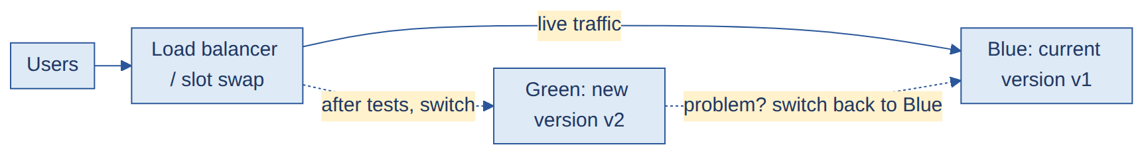

Q&A
Q1. Backup aur DR tumhare environment mein kaise kaam karte hain?
A. Azure Backup se VMs aur databases ka scheduled backup (retention policy ke saath, restore test). DR ke liye Azure Site Recovery VMs ko doosre region mein replicate karta hai, aur failover plan hota hai.
Q2. Multi-tier application ke liye DR kaise design karoge?
A. Har tier ke liye: web (multi-region + Front Door/Traffic Manager), app (Site Recovery ya redeploy via IaC), database (geo-replication/failover groups), aur ek tested runbook.
Q3. RPO aur RTO kya hain?
A. RPO = maximum acceptable data loss (time). RTO = maximum acceptable downtime. DR design inhi se decide hota hai.
Q4. Azure mein High Availability kaise achieve karte ho?
A. Availability Zones/sets, multiple instances behind Load Balancer, scale sets, aur zone/geo-redundant storage.
Q5. Zero-downtime deployment kaise karte ho?
A. Rolling, blue-green ya slot-swap deployment, health checks ke saath, aur traffic tabhi switch karo jab naya version healthy ho.
Q6. Rollback strategy kya hai? Real-time example?
A. Last known good artifact redeploy, slot swap back, ya blue-green mein traffic wapas. Database changes backward-compatible rakhte hain. (Apna asli rollback example yahan lagao.)
Q7. Deployment system aur end-user perspective se successful hai ye kaise verify karte ho?
A. System side: health checks, logs, metrics. End-user side: smoke tests, synthetic user-flow tests, aur monitoring dashboards.
Q8. Multi-region DR kaise design karte ho?
A. Secondary region mein replicated resources, global routing (Front Door/Traffic Manager), data replication, aur regular DR drills.

21. Cloud migration #MIGRATION CONCEPT

Samjho
- Migration flow: Assess (kya hai) → Replicate → Test migration → Cutover → Validate → Decommission.
- Bade migration mein pehle Landing Zone ready hota hai, phir servers waves mein jate hain.
- Honest rule: agar aapne production migration nahi kiya, to flow samjhao aur lab experience bolo.

Q&A
Q1. VM ko Azure mein migrate karne ka process?
A. Azure Migrate se discover aur assess, replication, test migration, cutover (short downtime), post-migration validation, aur phir source decommission.
Q2. 100+ servers ki migration CAF aur Landing Zone ke saath kaise karoge?
A. Pehle CAF ke hisaab se assessment aur strategy (rehost, replatform, refactor), Landing Zone ready, phir servers ko waves mein migrate, RPO/RTO ke hisaab se replication, aur automation (Terraform/pipelines).
Q3. Minimal downtime kaise rakhte ho?
A. Continuous replication pehle se, aur cutover ke time sirf final sync aur DNS/traffic switch. Test migration pehle se.
Q4. Migration ke dauran private VMs ko temporary internet access kaise doge?
A. NAT Gateway ya Azure Firewall se (specific FQDNs allow karke), VM ko public IP diye bina.
Q5. AWS workloads ko Azure mein kaise laate ho? Multi-cloud kaise manage karte ho?
A. Azure Migrate AWS VMs ko bhi assess/replicate karta hai. Multi-cloud ke liye Terraform (multi-provider), Azure Arc, common monitoring aur policy.

22. Azure App Service / PaaS #APPSVC CONCEPT

Samjho
- PaaS mein OS, patching aur platform Azure sambhalta hai. Aap sirf code aur config dekhte ho.
- App Service: web apps/APIs host karne ka PaaS. Static Web Apps: static front-end (React/Angular) + serverless API. Container Apps: serverless containers, bina cluster manage kiye.

Q&A
Q1. Kaunsi PaaS services par kaam kiya hai?
A. App Service, Azure Functions, Azure SQL, Storage, Key Vault jo aapne actually use kiya ho wahi bolo.
Q2. App Service kya hai aur application kaise deploy karte ho?
A. Web apps host karne ka managed service. Pipeline mein AzureWebApp task ya ZIP deploy se, aur deployment slot par deploy karke swap.
Q3. Azure automatically kya manage karta hai App Service mein?
A. OS aur runtime patching, platform HA, load balancing aur infra scaling. App code, config aur security settings aapki zimmedari hain.
Q4. App Service traffic ko restrict aur secure kaise karte ho?
A. Access restrictions (IP/VNet), Private Endpoint, HTTPS only, Managed Identity, aur Dev/Test ko public access se band rakhna.
Q5. Dev/UAT/Prod App Services kaise manage aur promote karte ho?
A. Alag apps/plans ya deployment slots. Lower environment mein test karke pipeline ya slot swap se promote karte hain.
Q6. Static Web Apps vs App Service? React app SWA par kaise deploy karoge?
A. Static Web Apps static front-end ke liye hai (free SSL, CDN, serverless API), App Service server-side apps ke liye. React ko npm run build se build karke pipeline/GitHub Action se (AzureStaticWebApp task) deploy karte hain.
Q7. Azure Container Apps kya hai?
A. Serverless container platform jahan Kubernetes manage kiye bina containers chalte hain aur auto-scale hote hain.

23. Scripting aur automation #SCRIPT CONCEPT

Samjho
- Bash (Linux, pipeline steps), PowerShell/Azure CLI (Azure automation), Python (basic automation, API/data).
- Interview mein sirf wahi bolo jo aapne use kiya ho, aur ek chhota example ready rakho.

Q&A
Q1. Kaunsa automation implement kiya hai? Kaunsi scripting languages aati hain?
A. Apne asli kaam se example do (jaise resources list karna, cleanup, access task). Languages mein Bash, PowerShell aur Python jo aati hon wahi.
Q2. Azure DevOps mein PowerShell/Bash se automation ka example?
A. Pipeline ke script/PowerShell task se Azure CLI commands chalana, jaise resource group banana, tags set karna, ya report generate karna.
Q3. Azure resources ki information kaise collect karte ho?
A. az resource list -o table ya Azure Resource Graph query se, aur Python/PowerShell se output ko file/report mein badal kar.
Q4. Python mein resource names ka case (upper/lower) alag ho to?
A. Dono taraf .lower() (ya casefold()) se normalize karke compare karte hain.
Q5. Security tools bina CI/CD ke Linux par chal sakte hain?
A. Haan, CLI se seedha ya cron/schedule se. CI/CD sirf automation aur enforcement ke liye hai.
Q6. AI-driven automation aur Copilot DevOps mein kaise kaam aate hain?
A. Scripts aur YAML draft karne, errors samajhne aur logs summarize karne mein. Output ko hamesha review aur test karke use karte hain. (Jitna aapne use kiya utna hi bolo.)

24. Kubernetes / AKS (common questions, basic level) #K8S CONCEPT
IMPORTANT Aapka abhi Docker tak ka hands-on hai. Ye sirf tab kaam aayega jab interviewer Kubernetes poochhe. Bolo: "Mera hands-on abhi Docker tak hai, Kubernetes ke basics seekh raha hu," aur phir neeche ke concepts bol do.

Samjho
- Kubernetes containers ko chalane, scale aur manage karne ka platform hai. AKS = Azure ka managed Kubernetes (control plane Azure sambhalta hai).
- Pod = sabse chhoti unit (ek ya zyada containers). Deployment pods ko chalata aur update karta hai. Service pods ko stable endpoint deta hai. Ingress HTTP routing deta hai.

Diagram: Kubernetes cluster
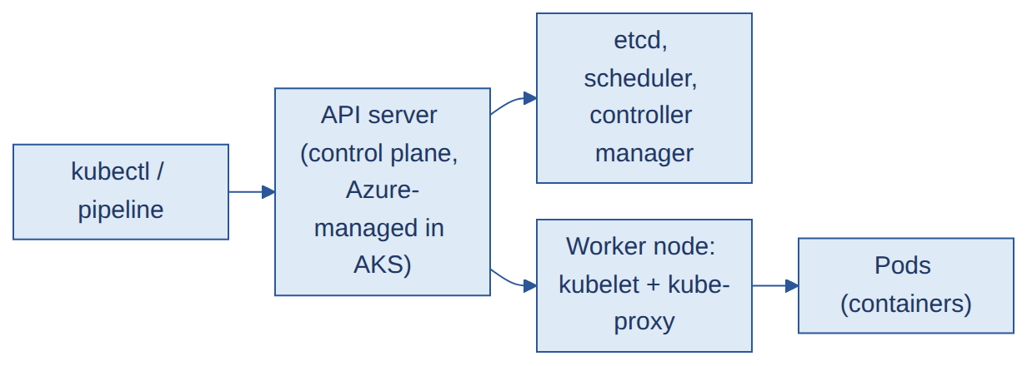

Q&A
Q1. Kubernetes aur AKS kya hain?
A. Kubernetes container orchestration platform hai. AKS Azure ka managed Kubernetes hai jisme control plane Azure manage karta hai aur hum worker nodes aur apps sambhalte hain.
Q2. AKS ke main components?
A. Control plane (API server, etcd, scheduler, controller manager) aur worker nodes (kubelet, kube-proxy, container runtime) jisme pods chalte hain.
Q3. Pod, Deployment aur Service mein kya fark hai?
A. Pod containers chalata hai. Deployment pods ki desired count aur updates manage karta hai. Service pods ko ek stable IP/DNS deta hai.
Q4. Load Balancer vs Ingress?
A. Load Balancer service type ek app ko external IP deta hai (Layer 4). Ingress ek hi entry point se HTTP/HTTPS URL ya host ke hisaab se kai services tak route karta hai (Layer 7).
Q5. ConfigMap aur Secret kya hain?
A. ConfigMap non-sensitive config store karta hai, Secret sensitive data (passwords, tokens). Secrets ko Key Vault (CSI driver) se manage karna behtar hai.
Q6. Kubernetes deployment strategies? Rolling vs Canary vs Blue-Green?
A. Rolling: pods dheere dheere naye version se replace hote hain. Canary: pehle thode users ko naya version. Blue-Green: do environments, traffic ek baar mein switch. Rolling sabse simple aur sasta hai, Blue-Green mein double resources lagte hain.
Q7. AKS cluster se kaise connect karte ho?
A. az aks get-credentials --resource-group <rg> --name <cluster> chalate hain, phir kubectl get nodes jaise commands.
Q8. Kubernetes mein application ko expose kaise karte ho?
A. Service (ClusterIP internal, LoadBalancer external) ya Ingress (Application Gateway/NGINX) se HTTP routing.
Q9. Private vs Public AKS cluster?
A. Private cluster mein API server ka private IP hota hai (internet se nahi), sirf VNet/private network se access. Public mein API server internet par reachable hota hai (access control ke saath).
Q10. Pod CrashLoopBackOff mein hai. Troubleshoot kaise karoge?
A. kubectl describe pod (events), kubectl logs <pod> (aur --previous), image/config/secret/resource limits check karo, aur recent deployment change dekho.
Q11. Deployment ko scale kaise karte ho?
A. Manually kubectl scale, ya HPA (Horizontal Pod Autoscaler) se CPU/memory ke hisaab se automatic.
Q12. AKS mein container images aur Terraform se AKS ko secure kaise karte ho?
A. Trusted registry (ACR) aur image scan, private cluster, RBAC aur Entra ID integration, network policies, aur Terraform mein least-privilege aur secrets Key Vault se.
Q13. Kuch common kubectl commands?
A. kubectl get pods, describe, logs, apply -f, delete, exec, rollout status/undo.
Har answer ke baad ek line apne kaam se jodo: "In my project I've done this for ..." Sirf wahi jo sach ho.

